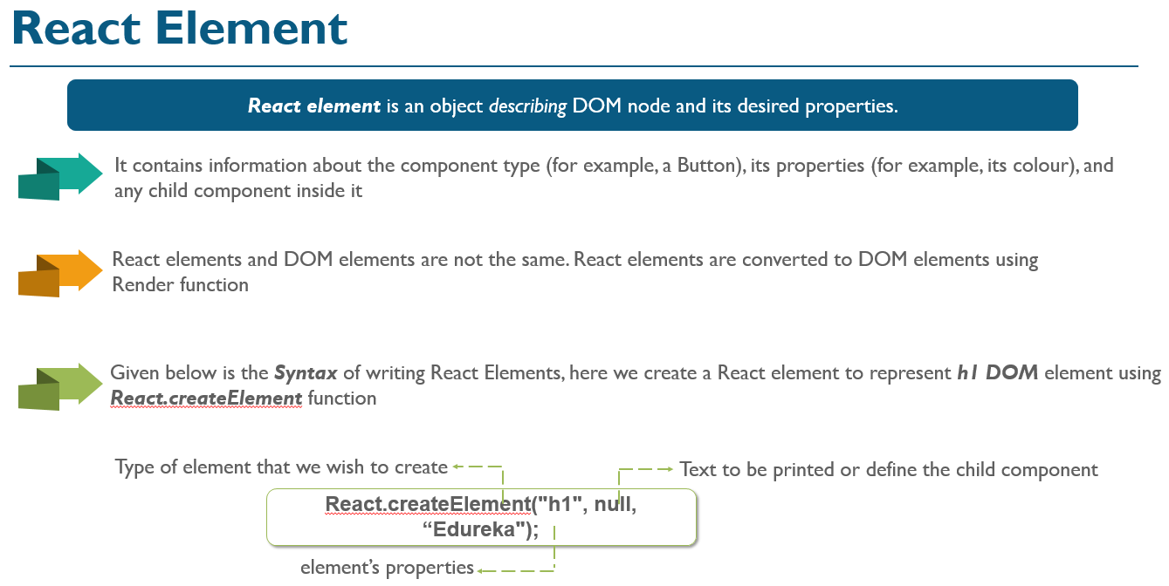
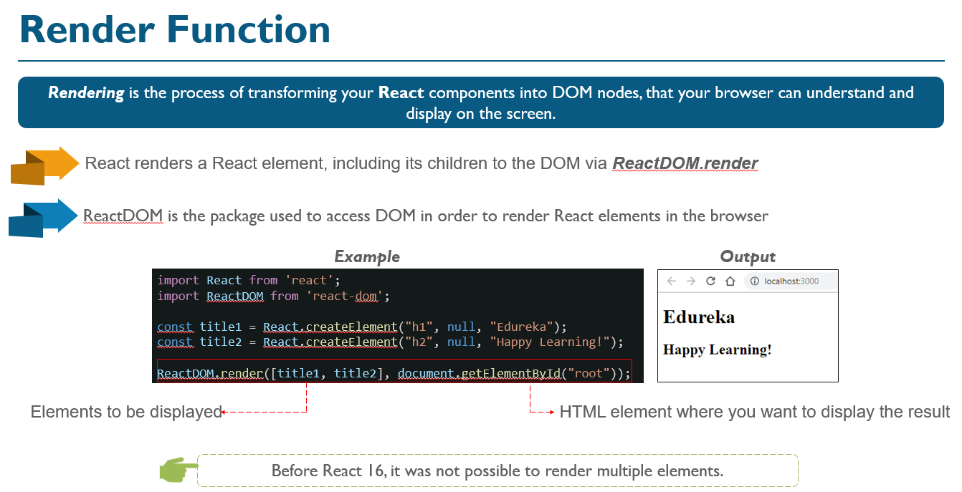
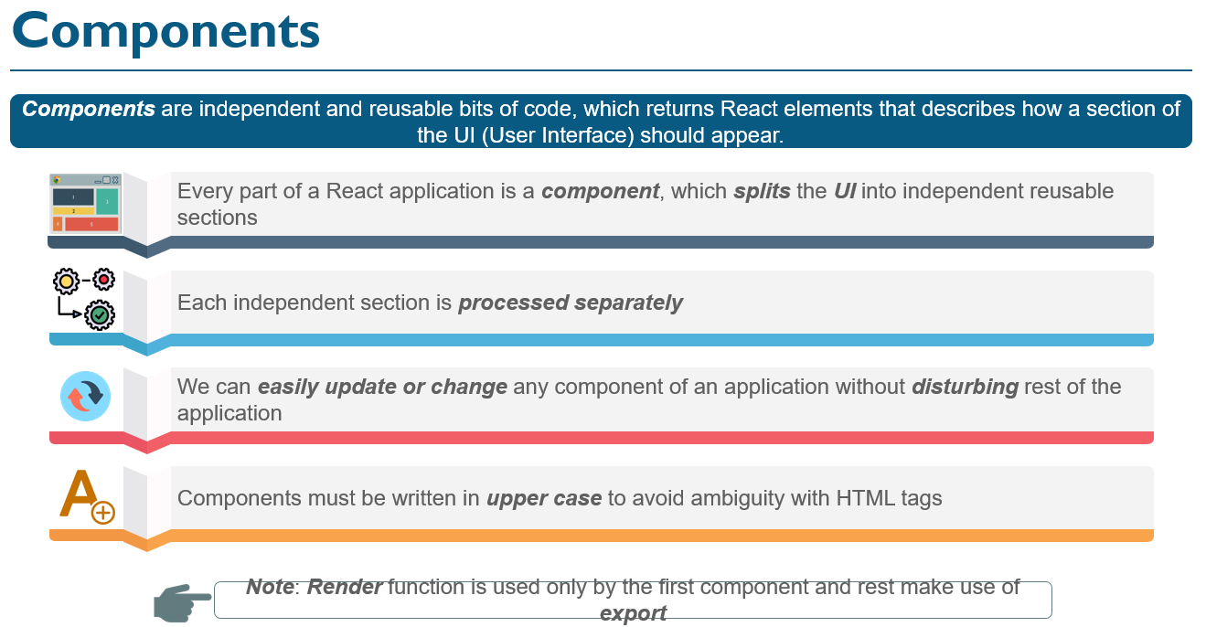
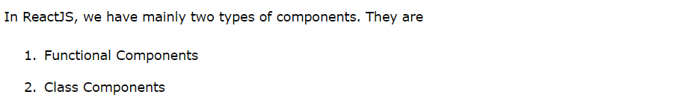
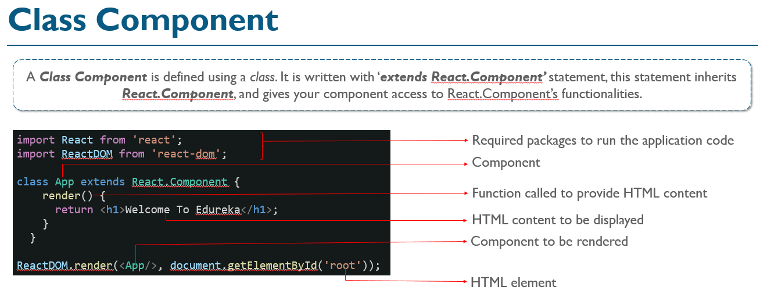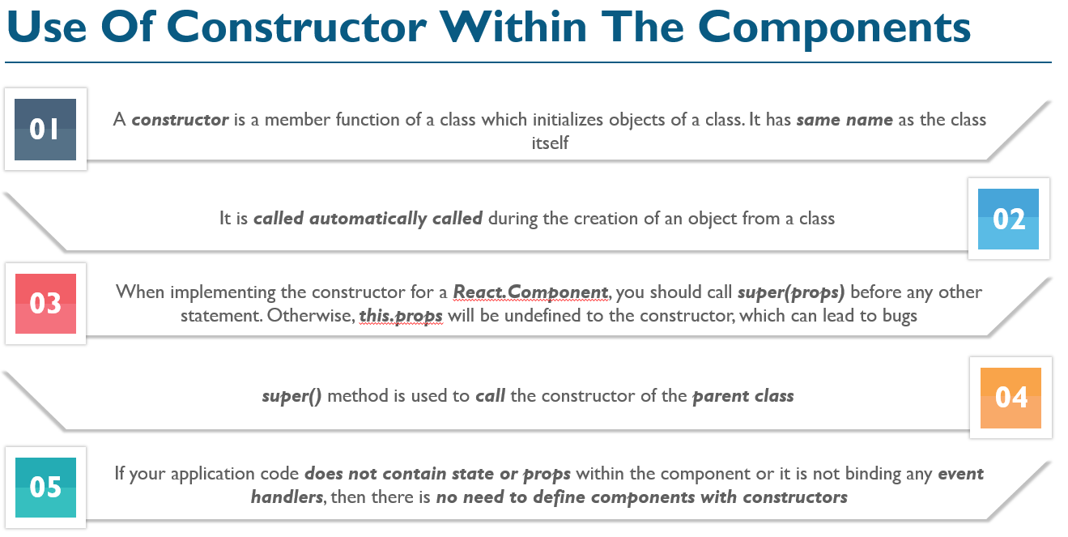
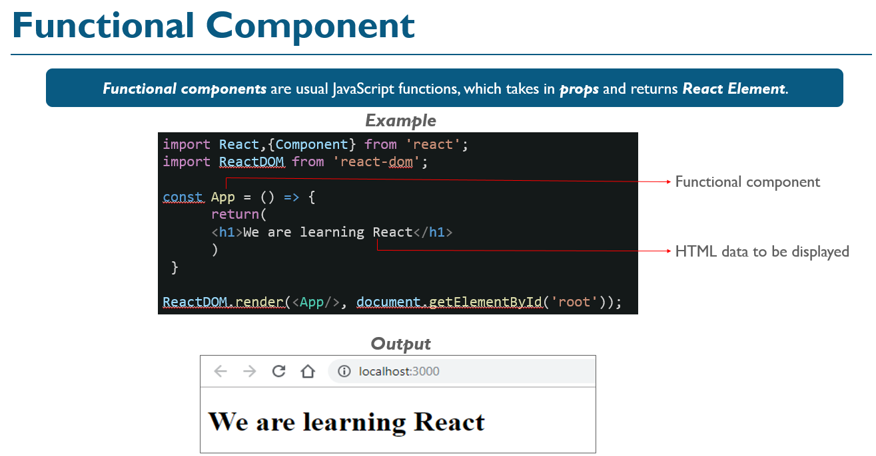
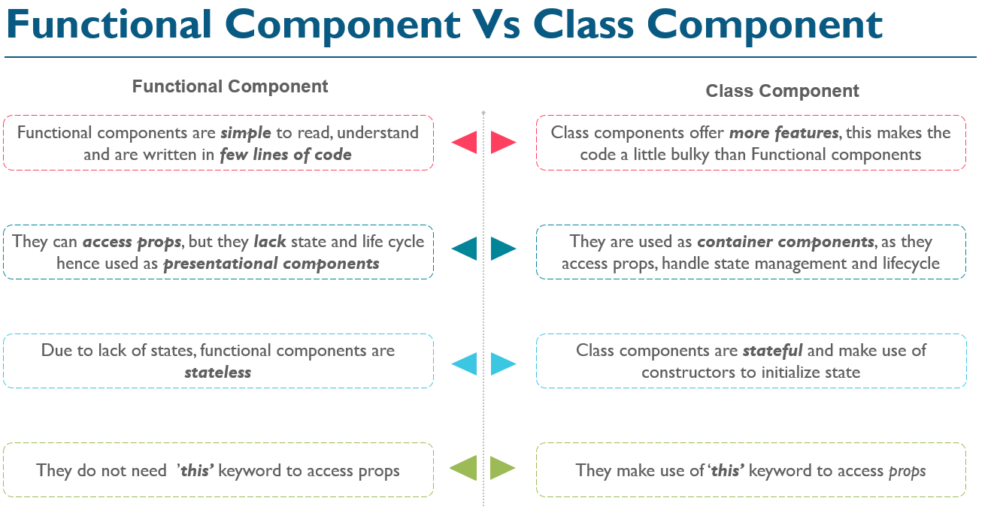
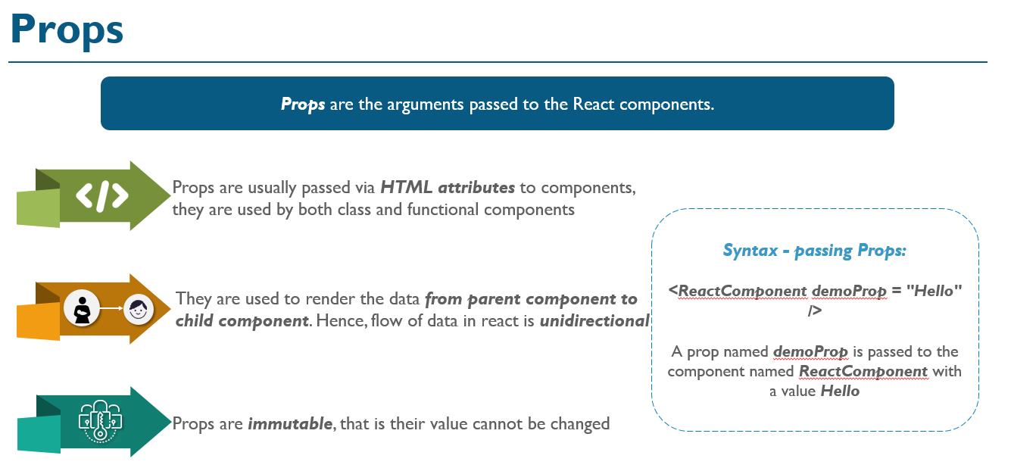
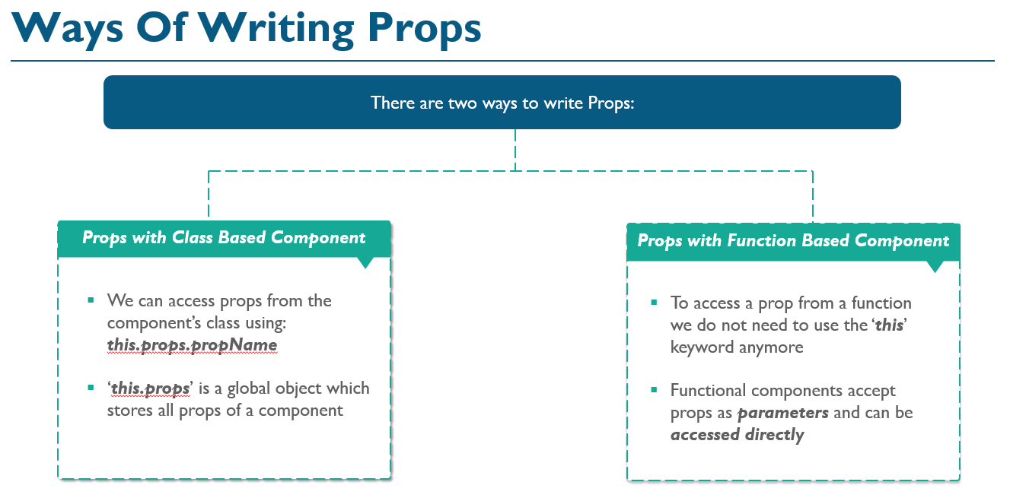
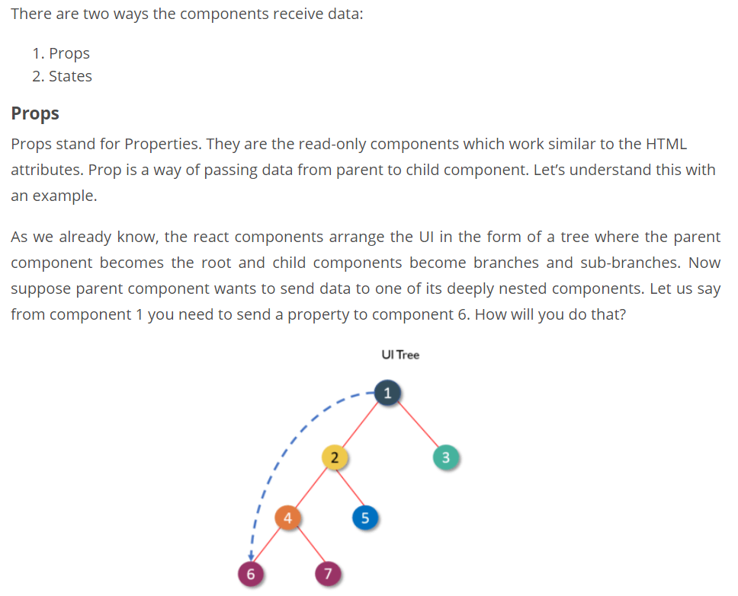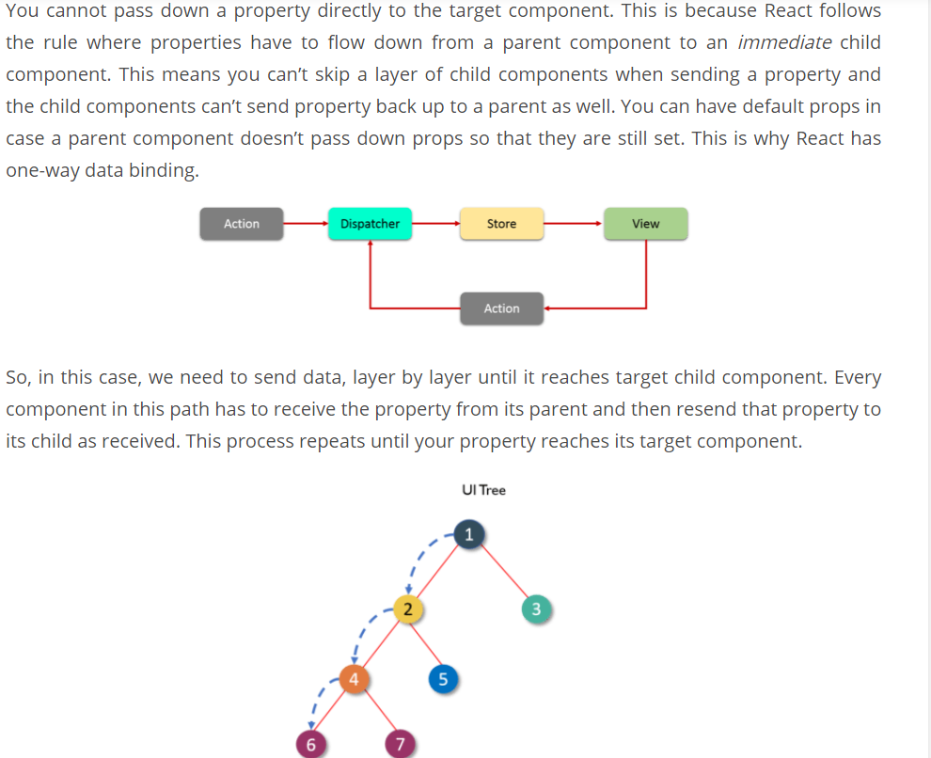
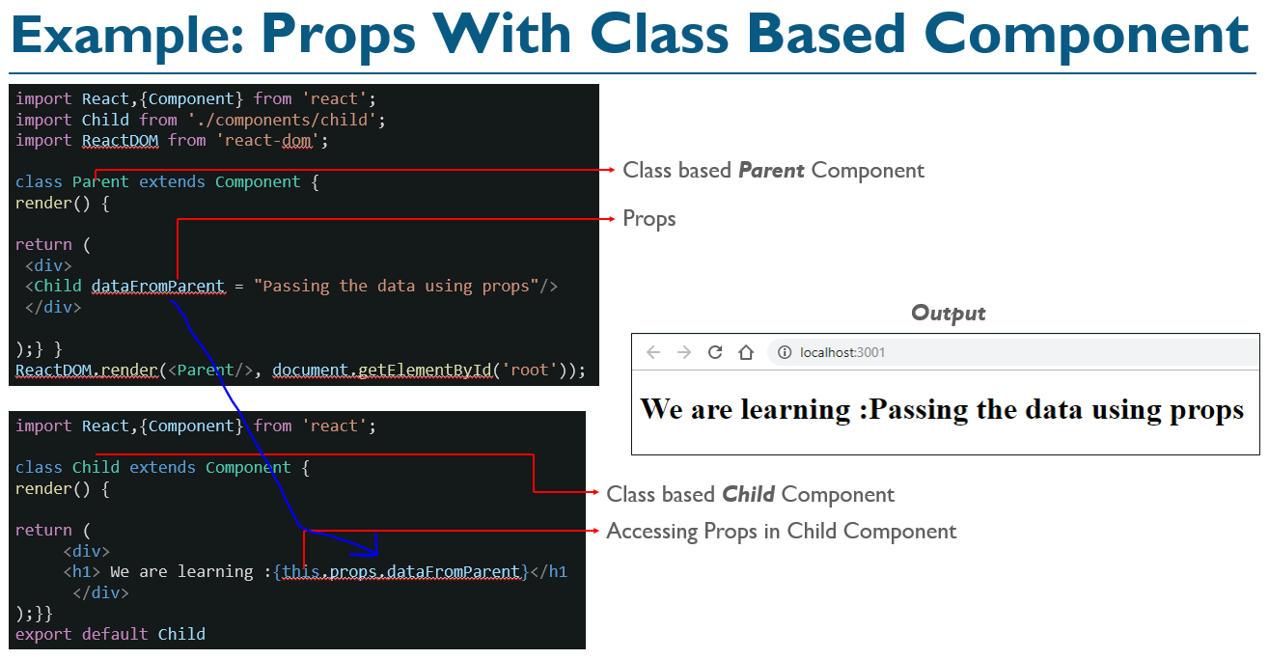
Note: Props are useful when a component is receiving data from its parent component, what should we use in-case if we have to receive data from some API?
Answer: States
Drawback of Props:
Since the props can only be passed from parent components, they cannot be changed. This makes them immutable and dumb. This poses a great challenge as the modern apps do not have all of its states ready on page load. Ajax or Events can happen when data returns, so someone needs to take responsibility for handling the updates. This is where React states come into the picture.
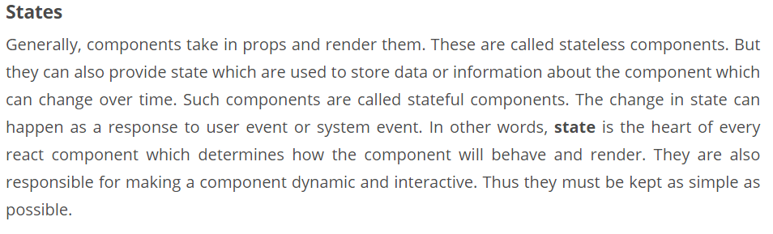
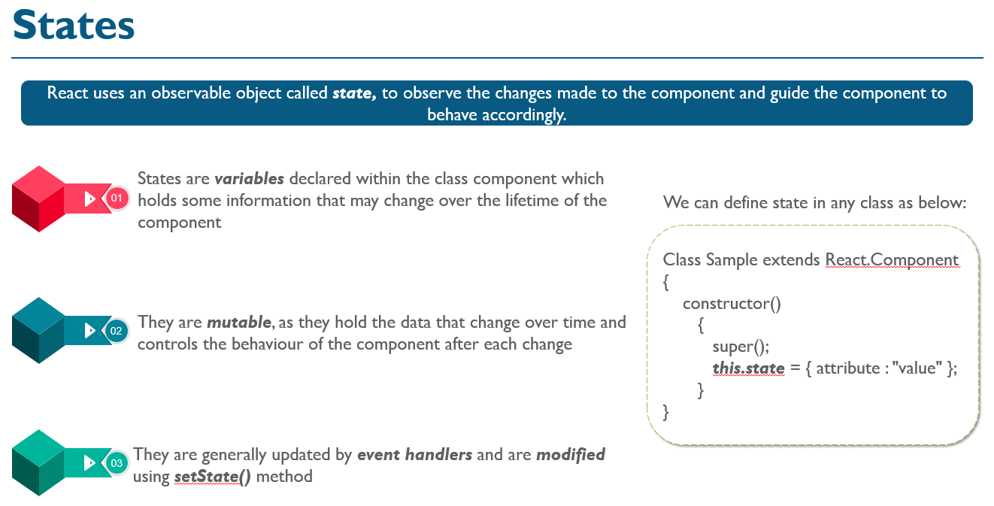
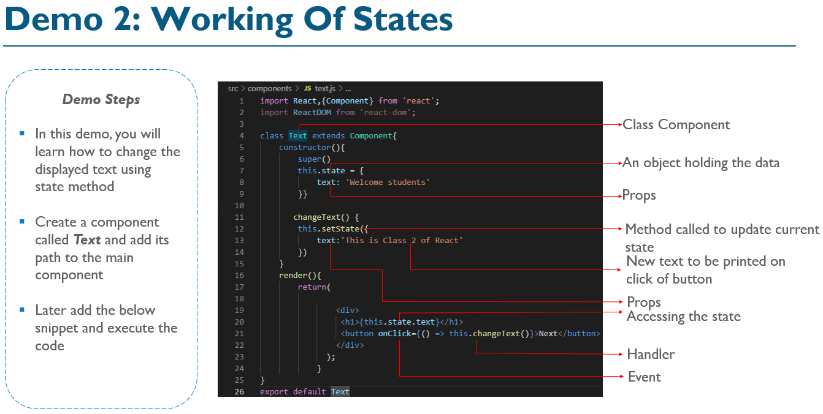
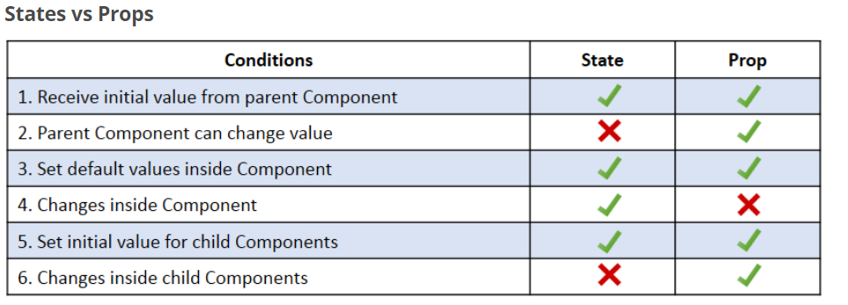
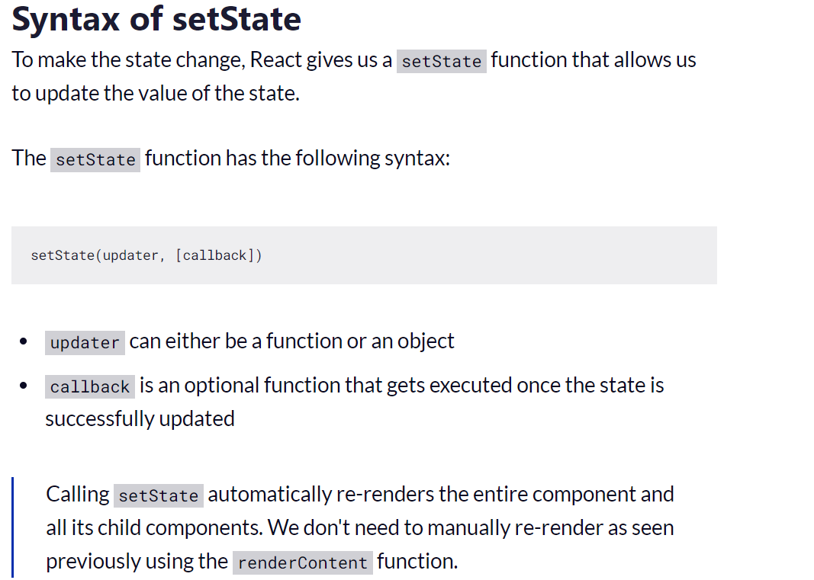

PropTypes
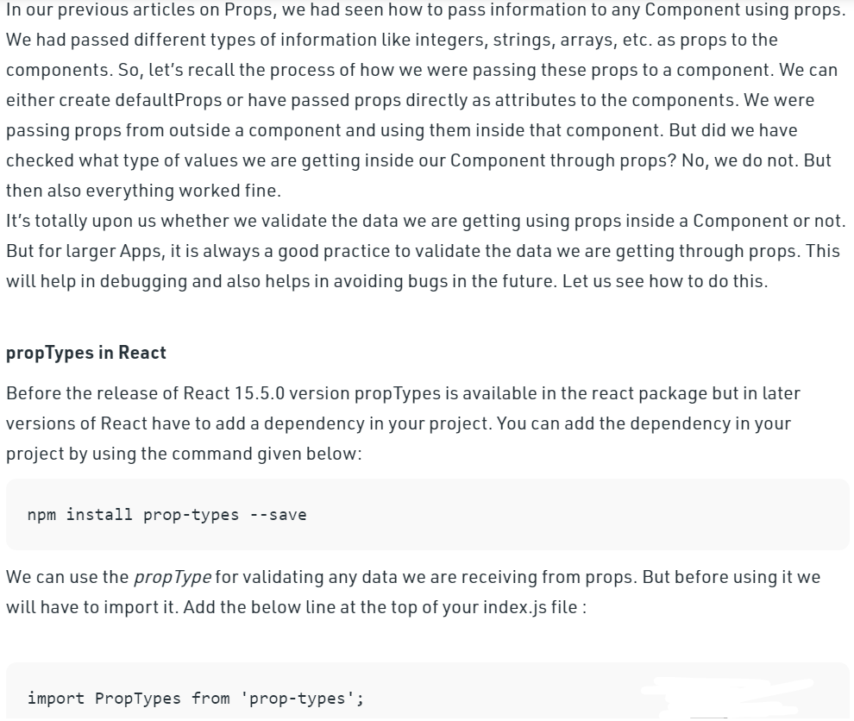
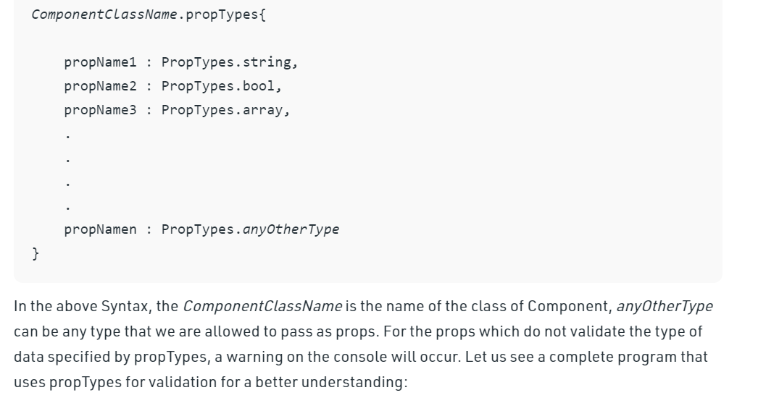

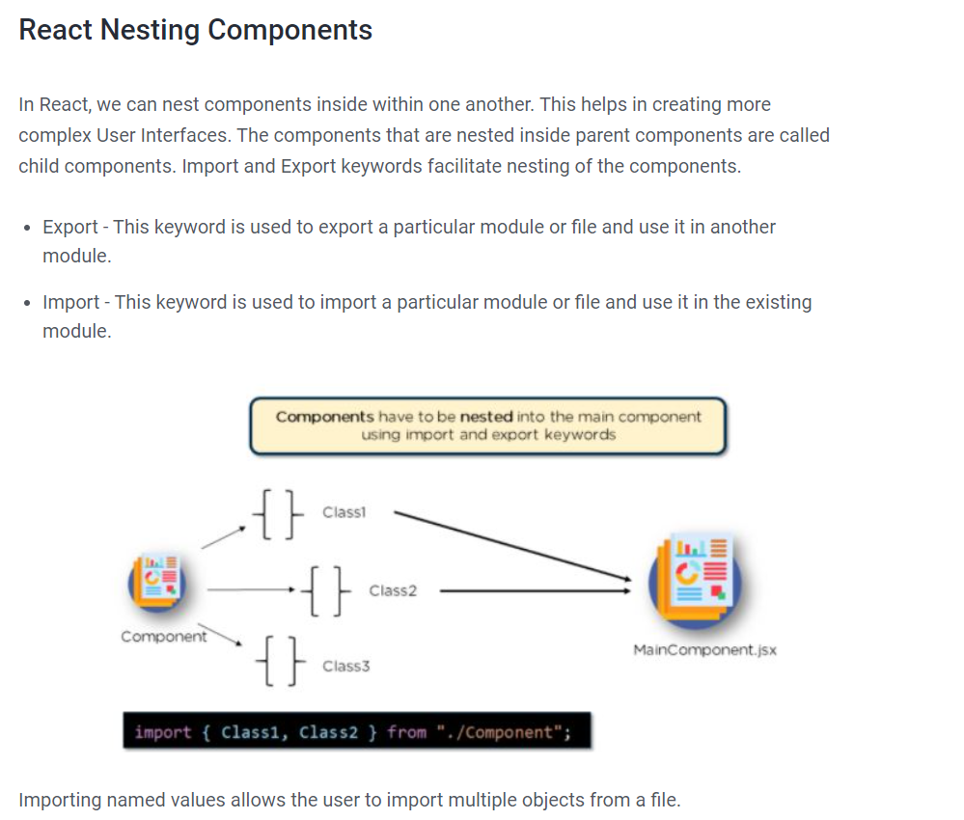

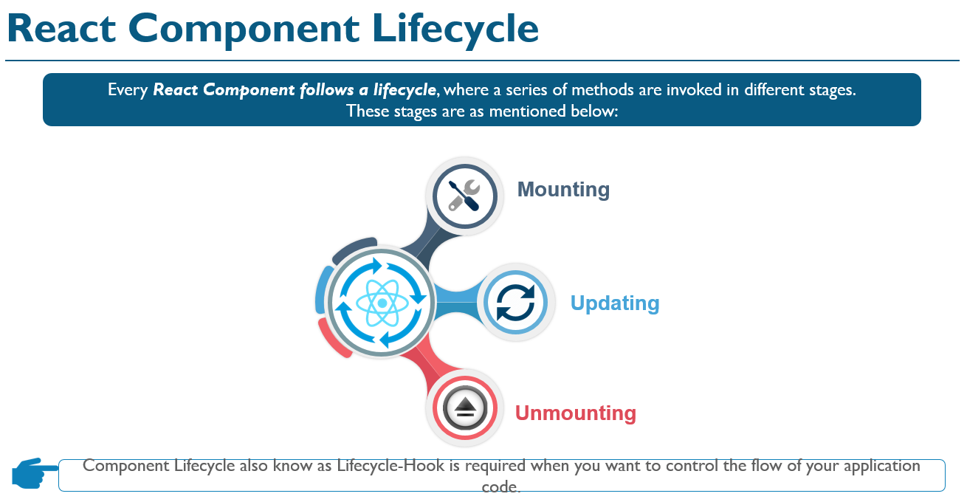
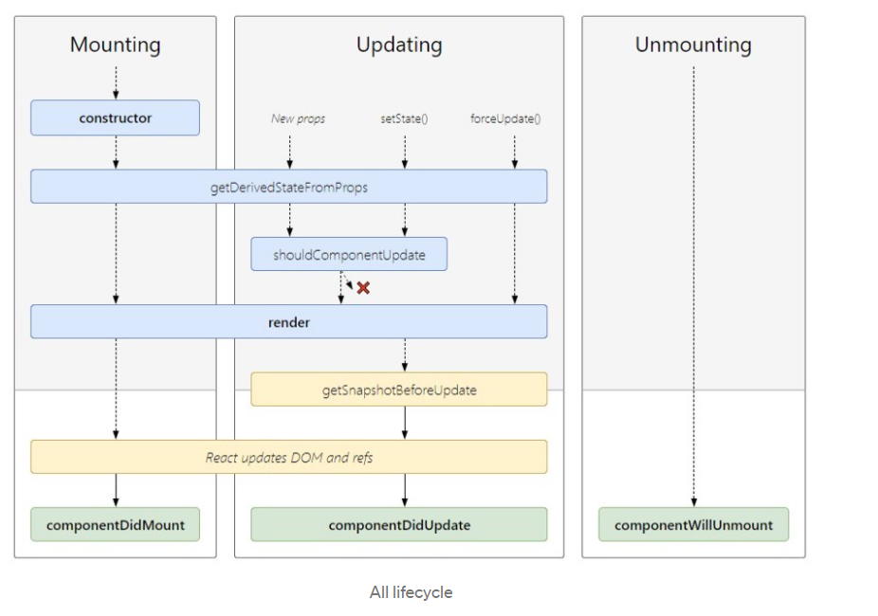
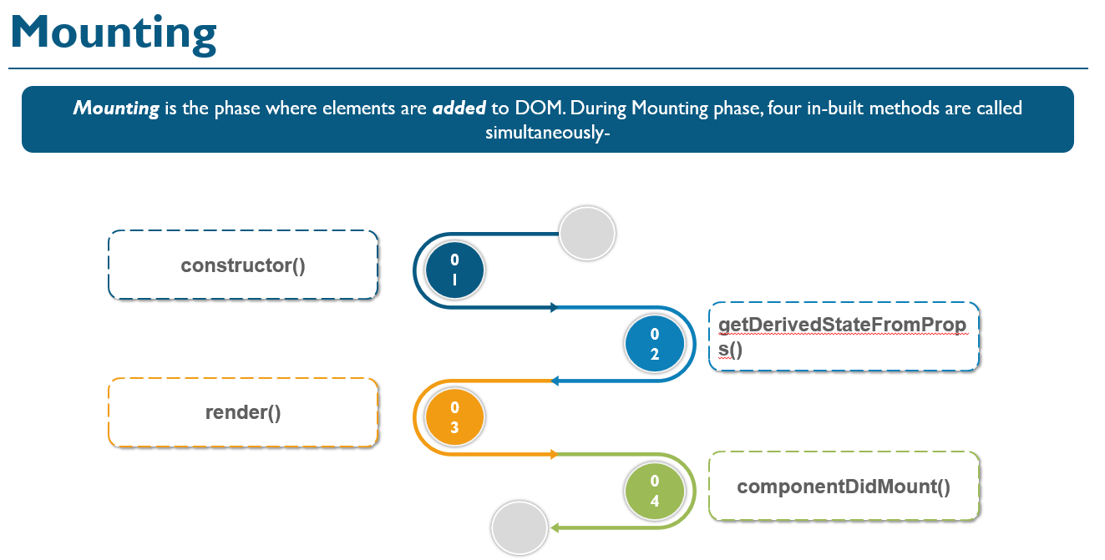
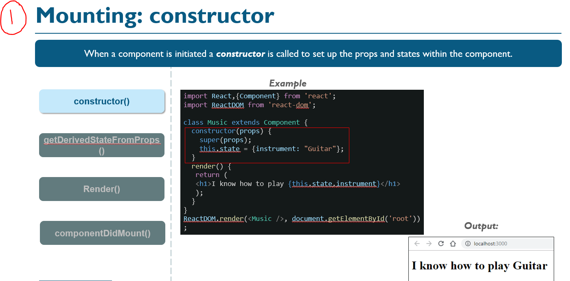
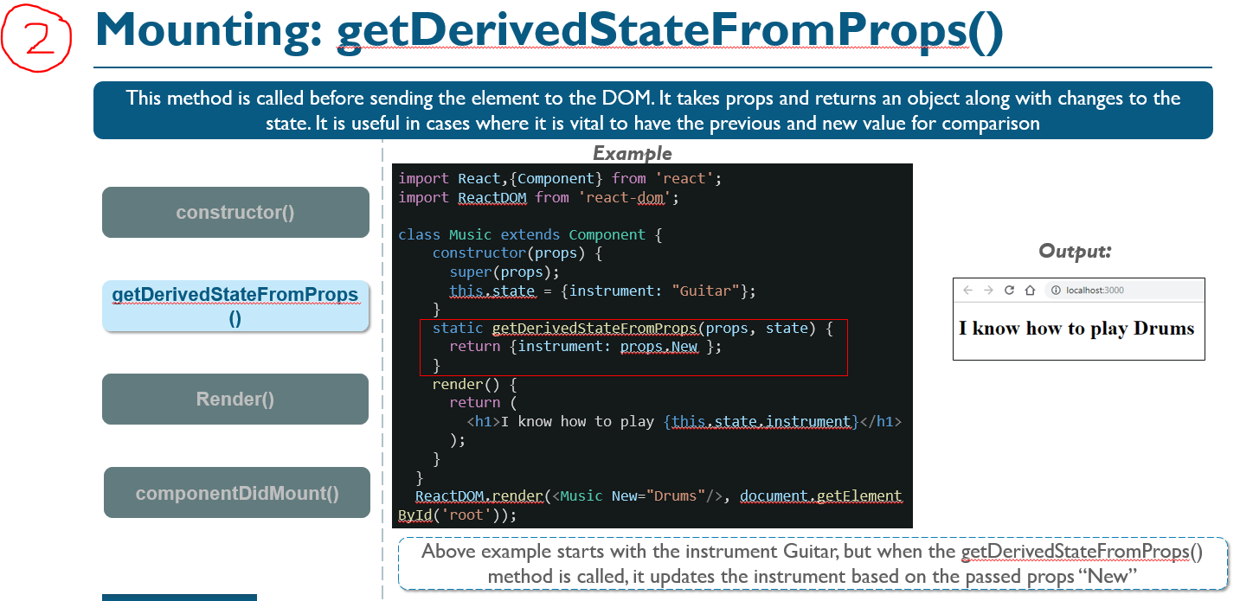

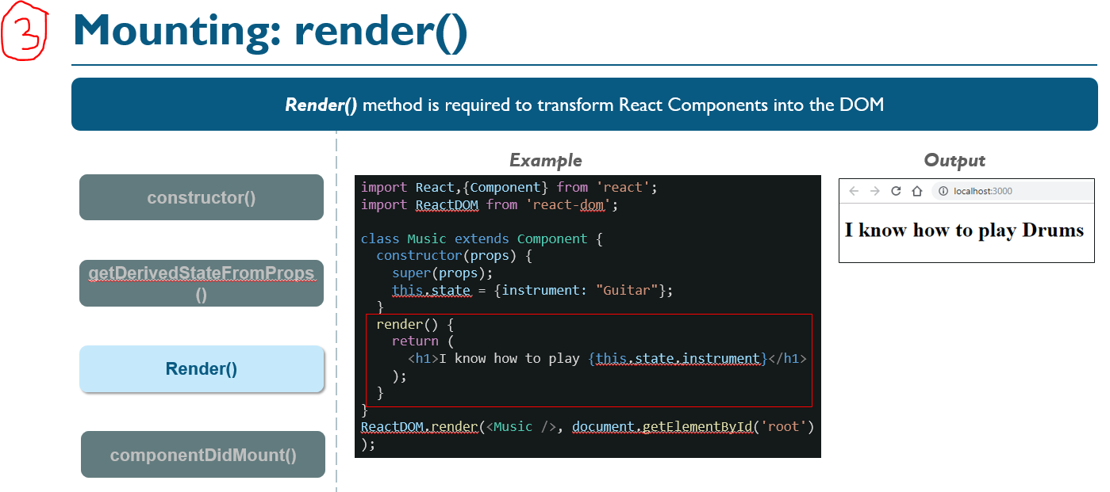

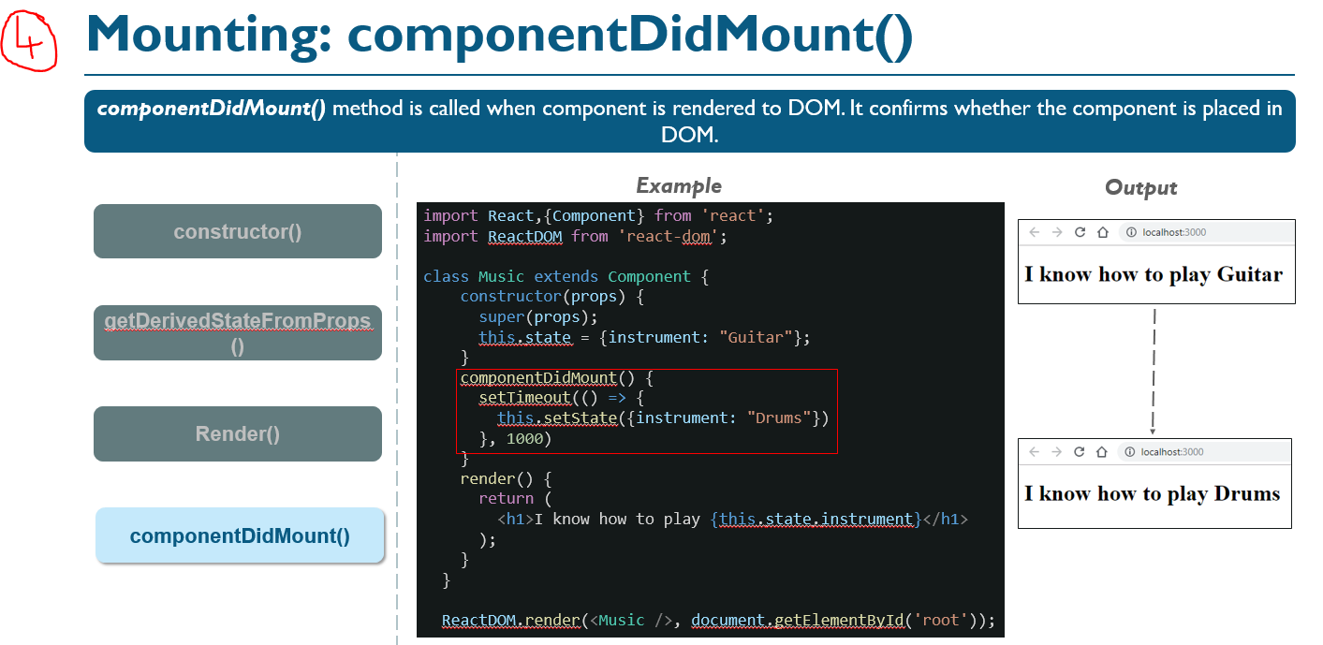
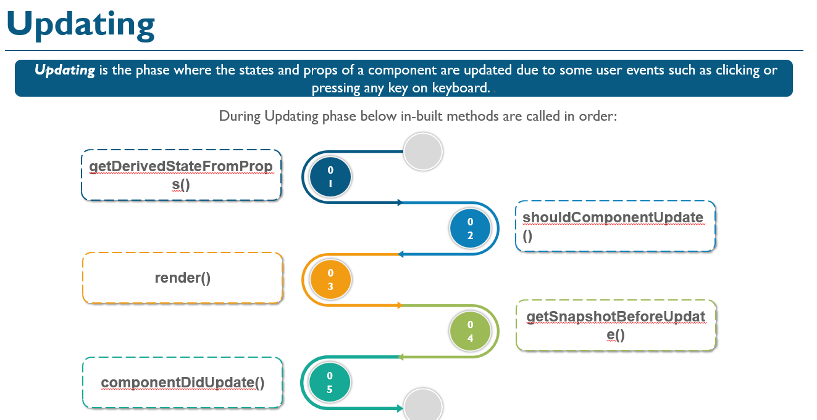
(1) getDerivedStateFromProps() and (3) render() methods are same as discussed before.
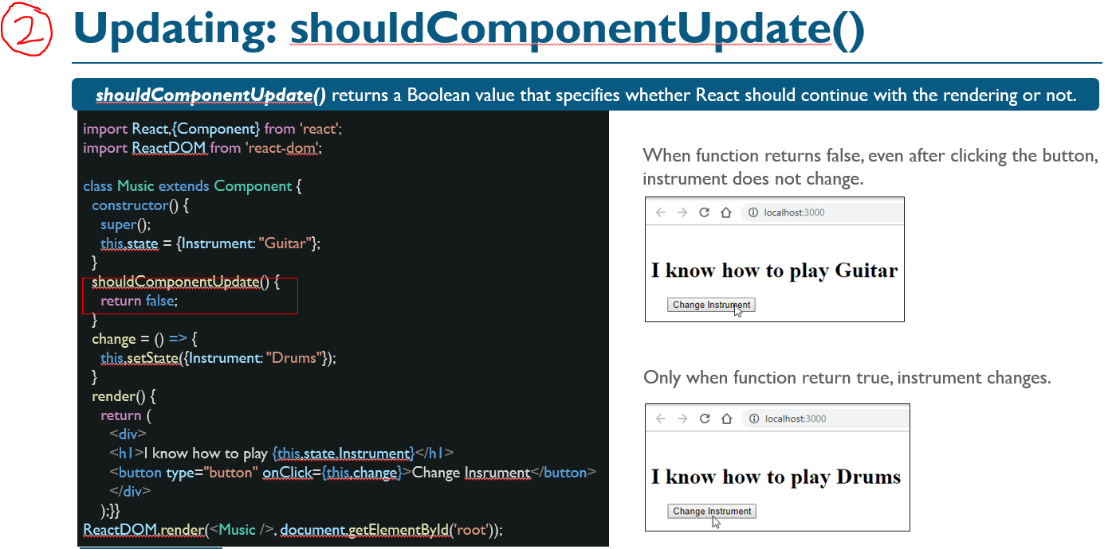
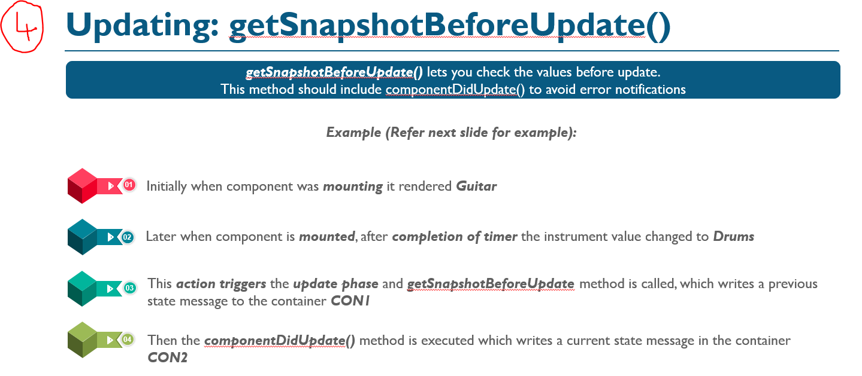
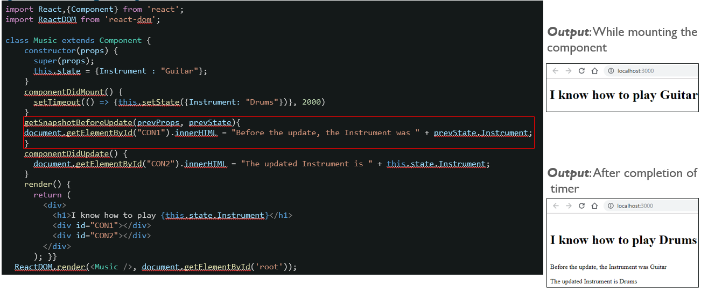

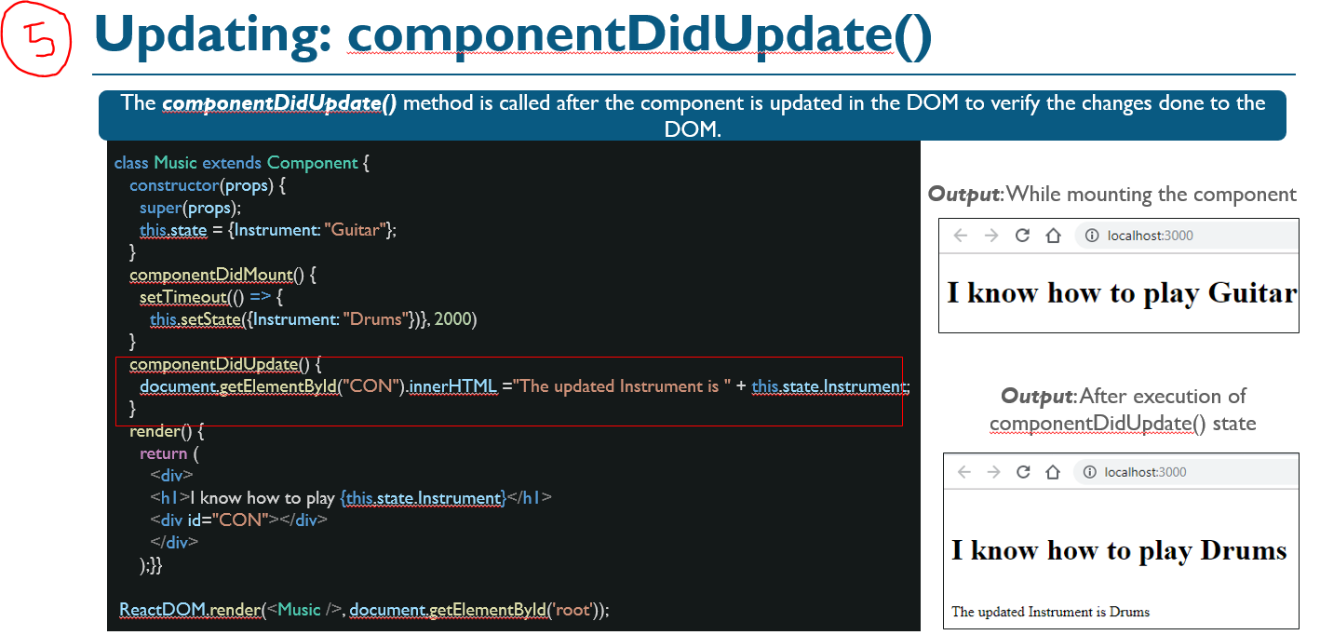

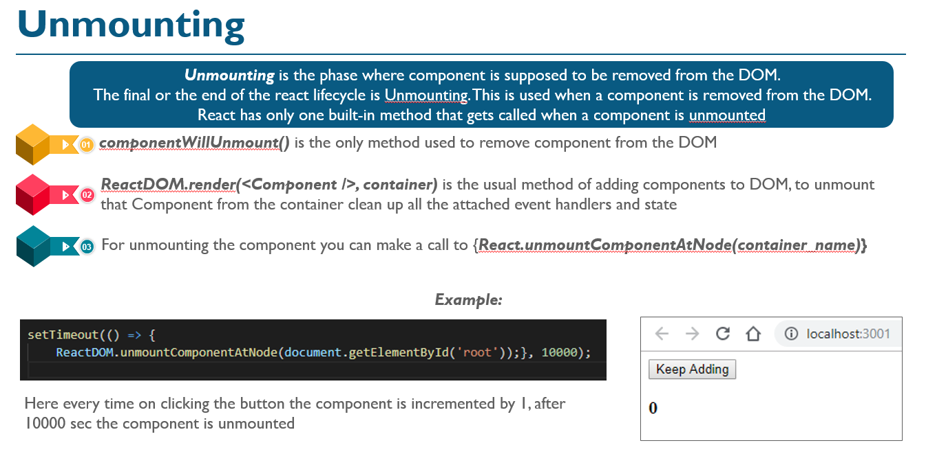
If there are any cleanup actions like cancelling API calls or clearing any caches in storage you can perform that in the componentWillUnmount method. You cannot use setState inside this method as the component will never be re-rendered.
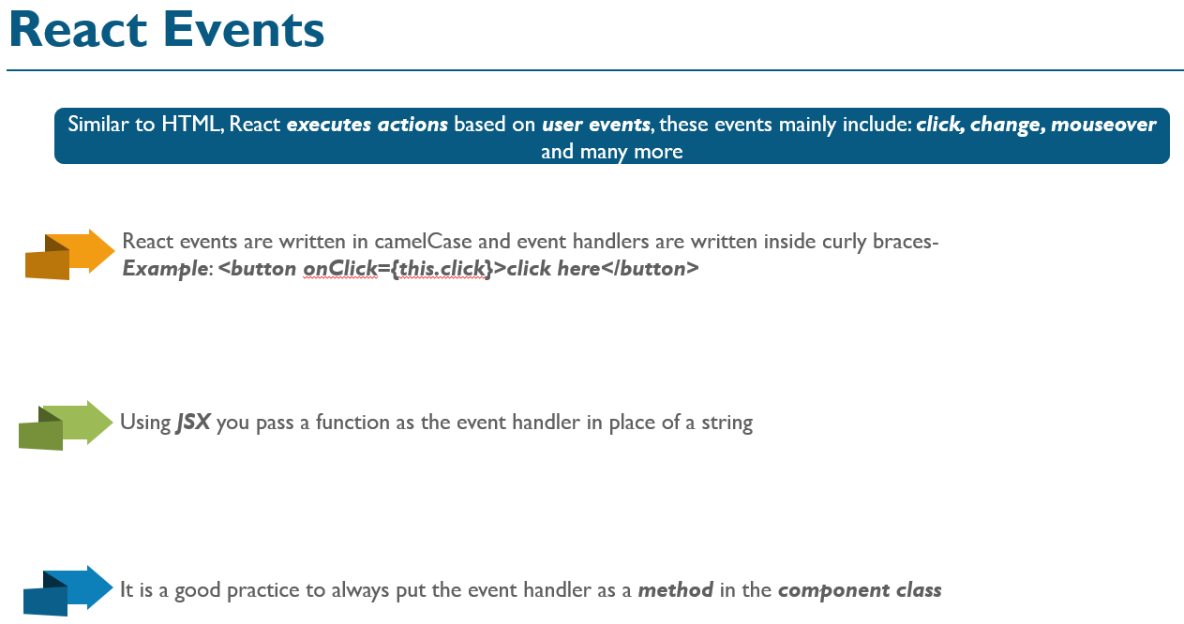
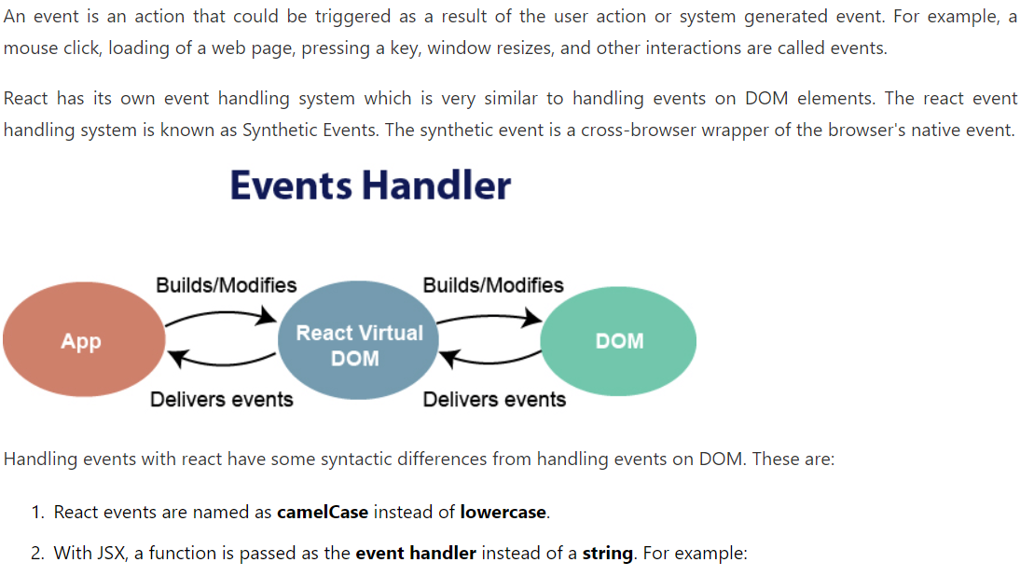
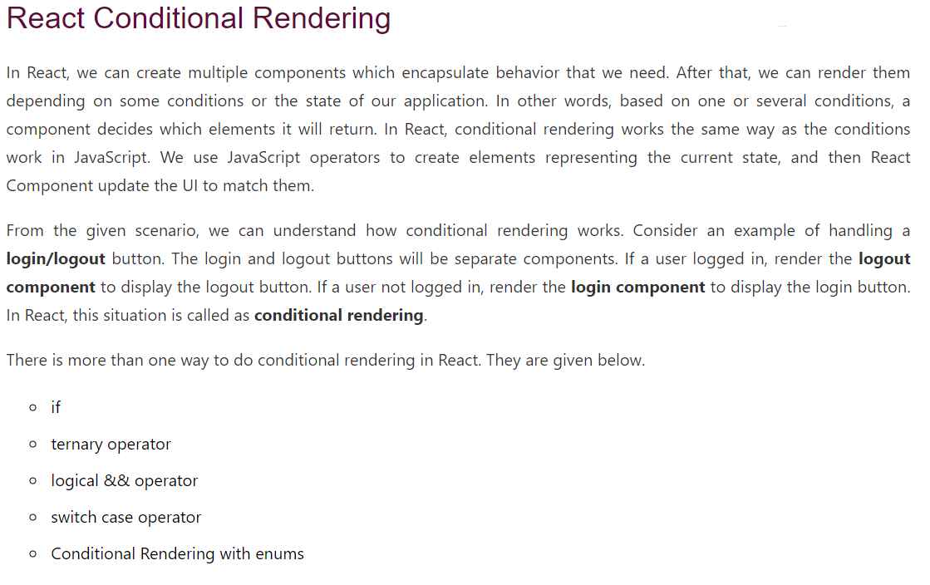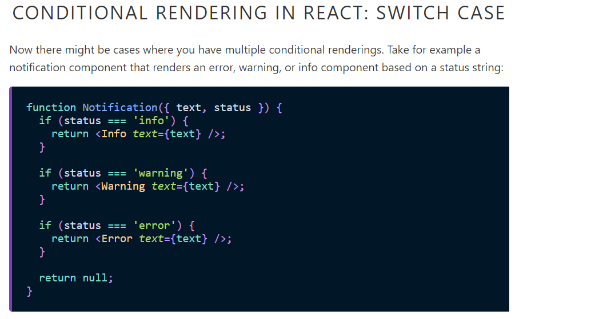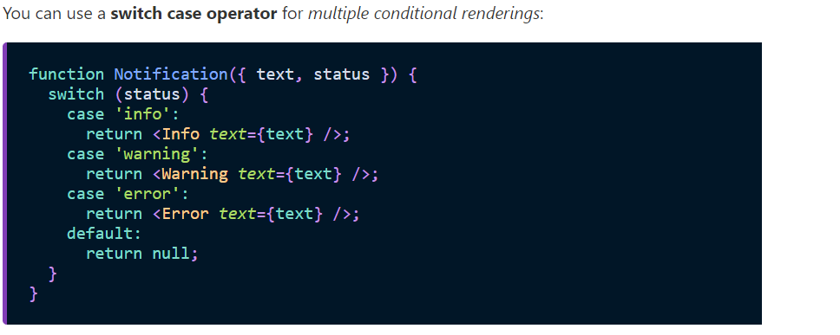
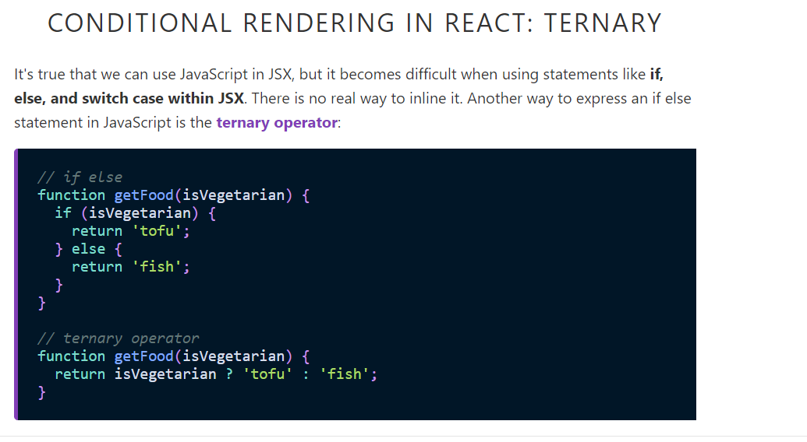
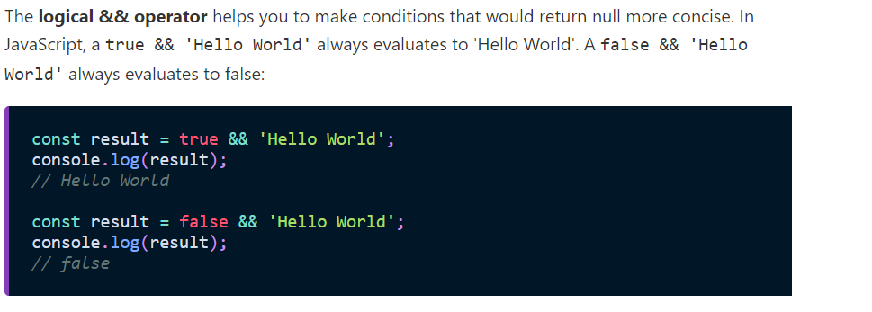
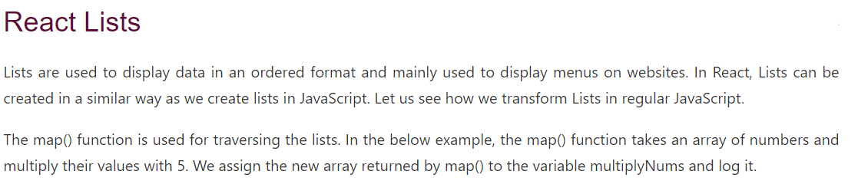
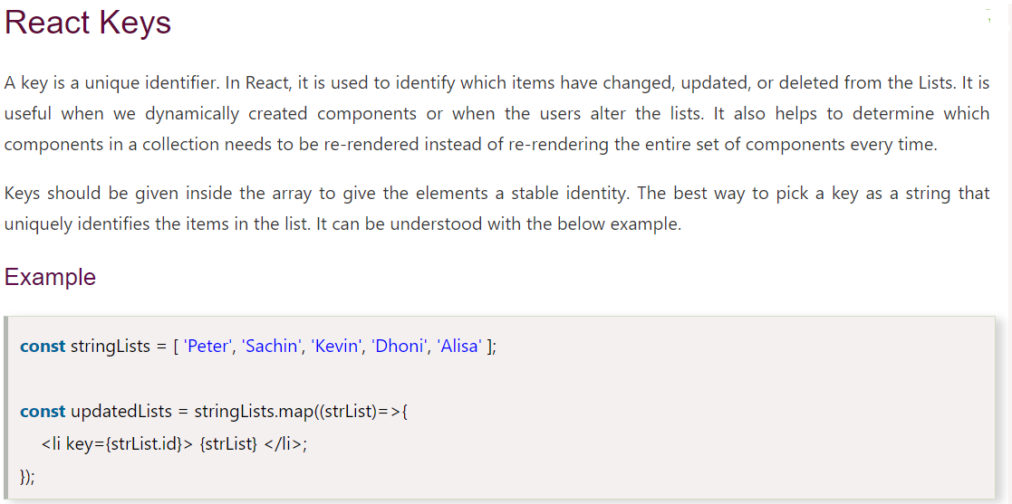

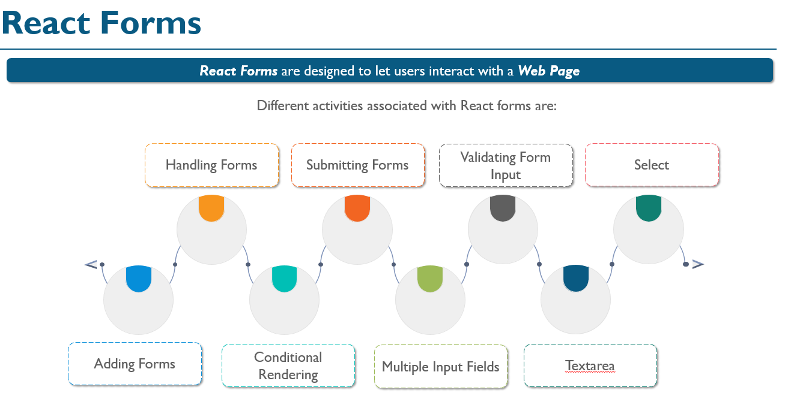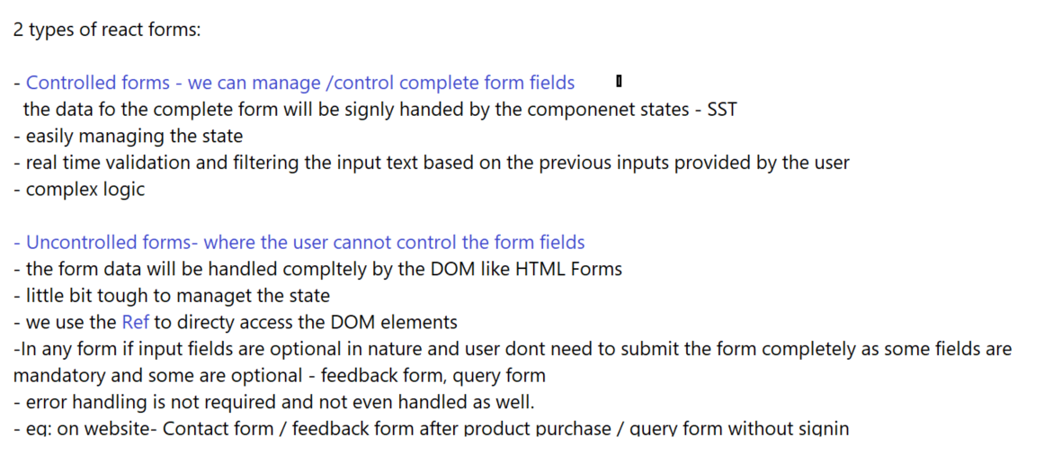

Single Page Application?
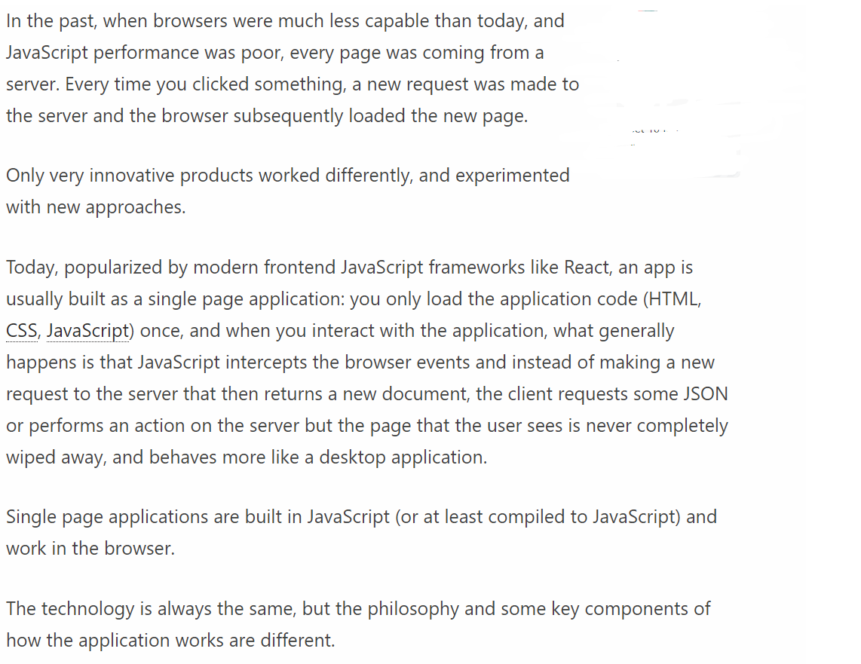



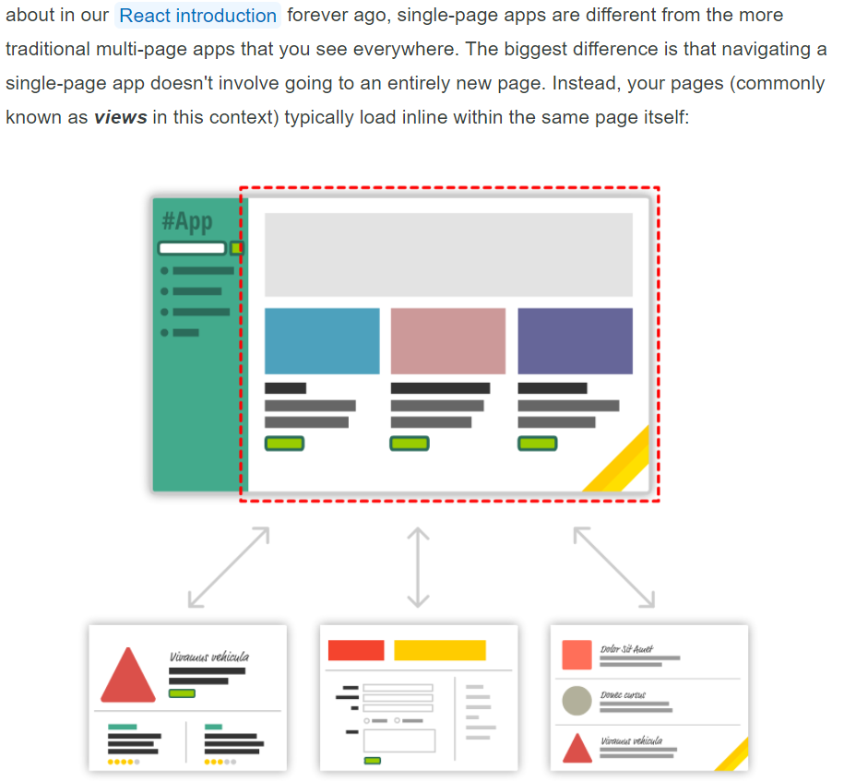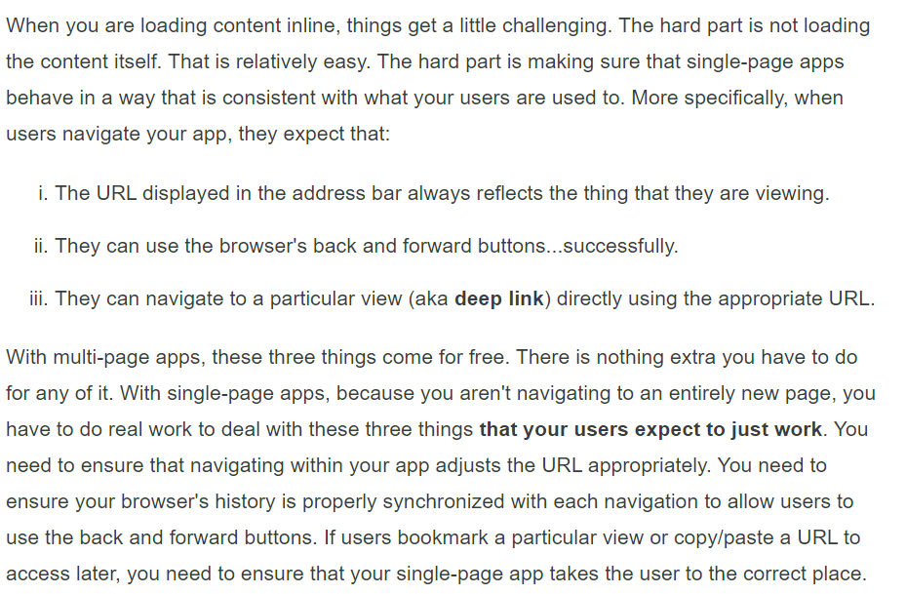
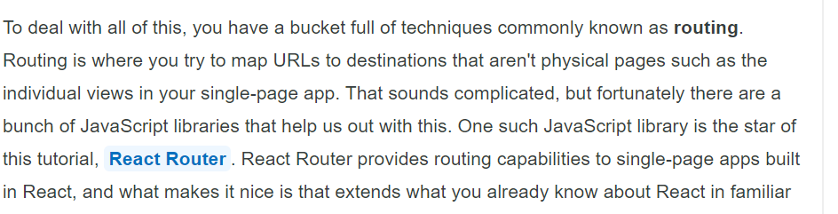
(reference below - https://www.kirupa.com/react/creating_single_page_app_react_using_react_router.htm )
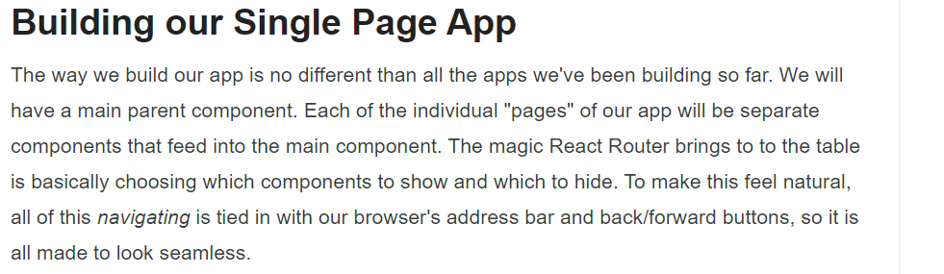
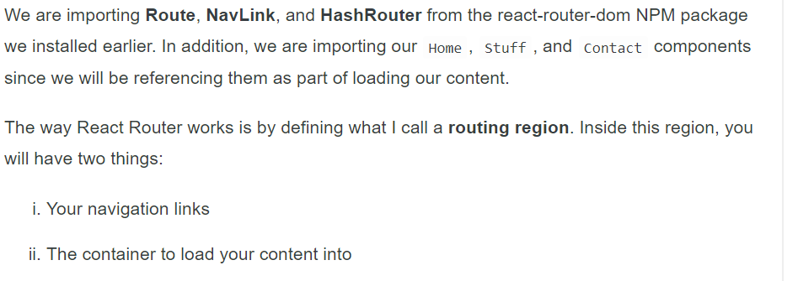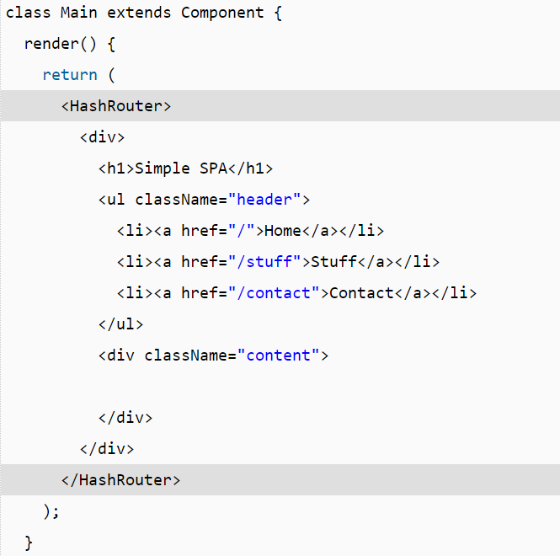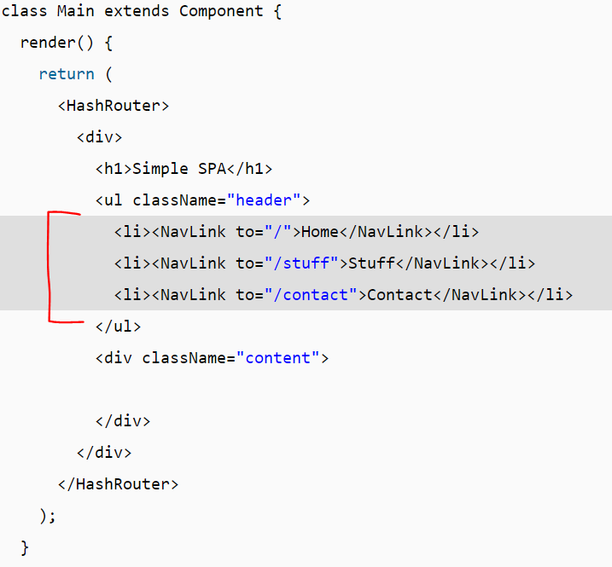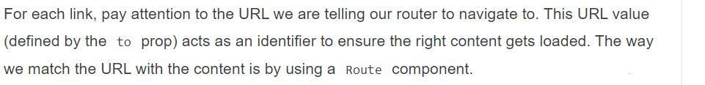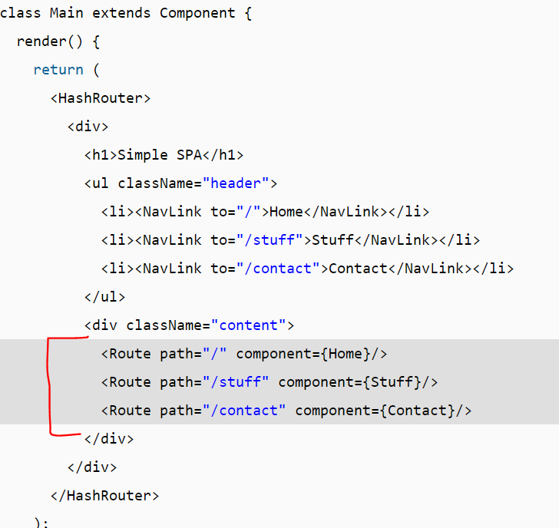
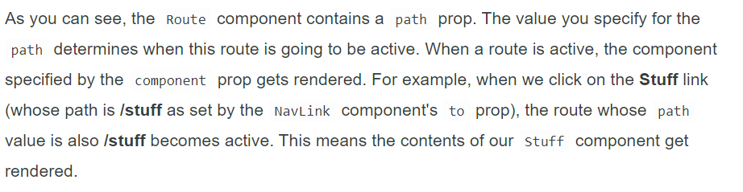
React High Order Components:
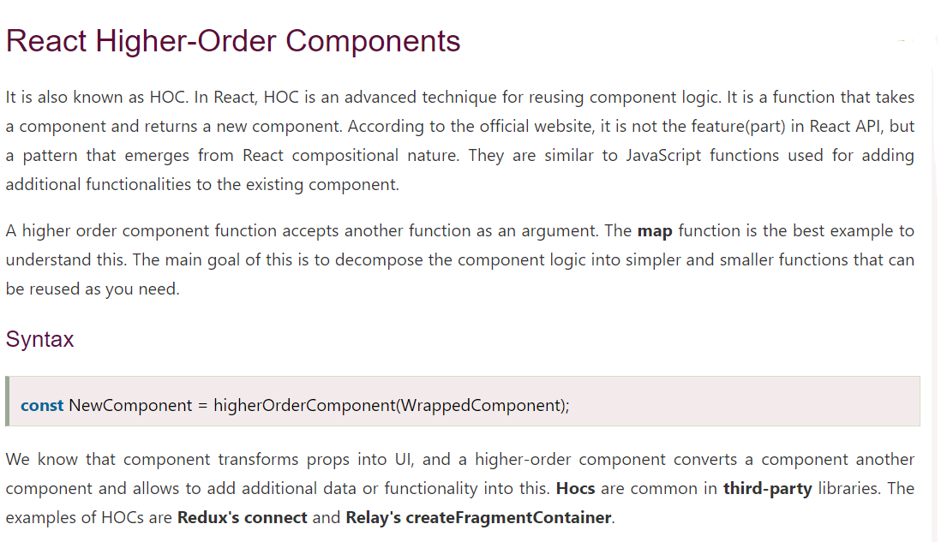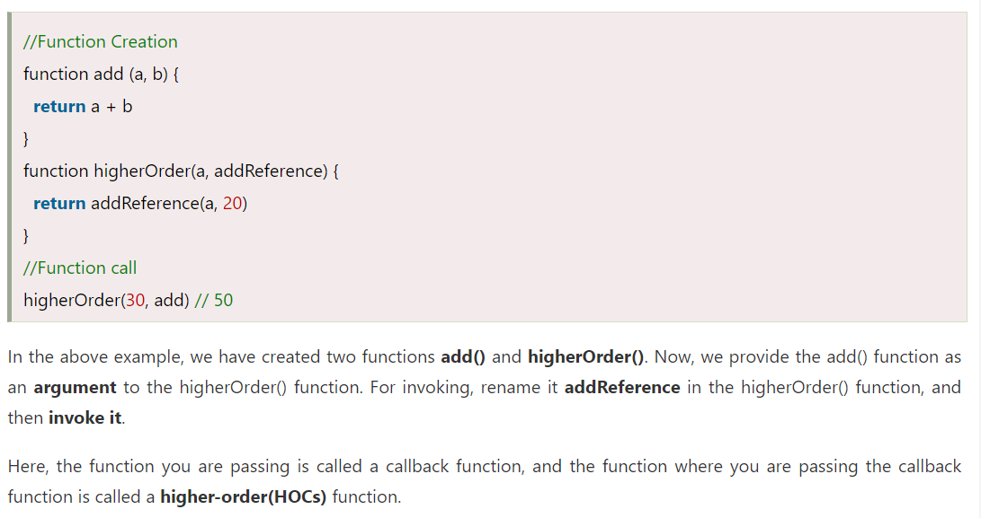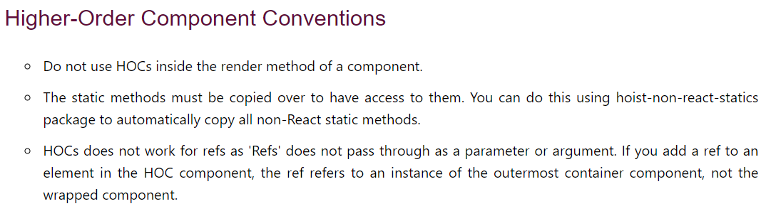
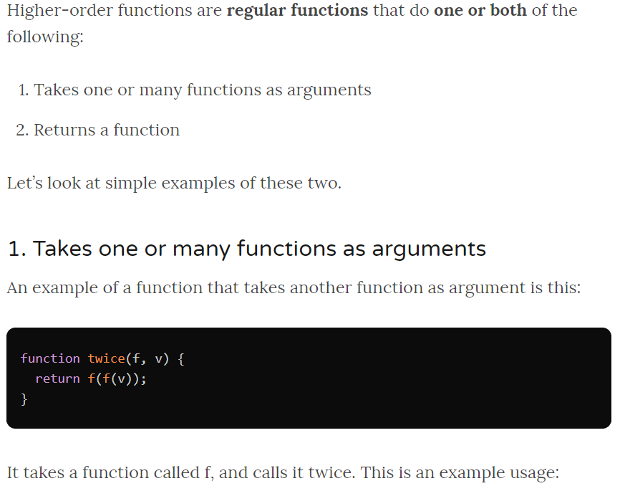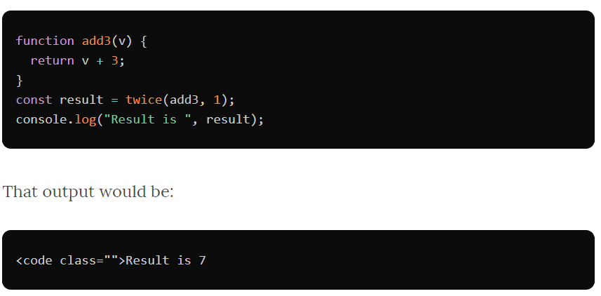

Render Props:

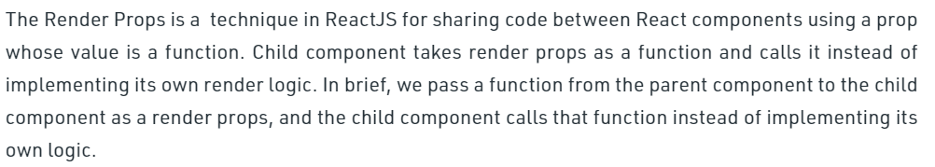

Code-sharing in React using Render Props
Render Props is an increasingly popular method of sharing code between react components. They are called Render Props (or render-props) because they allow “sharing code” via a render prop. But for this exercise, we’ll do the same while sharing code with react’s own children prop for aesthetics.
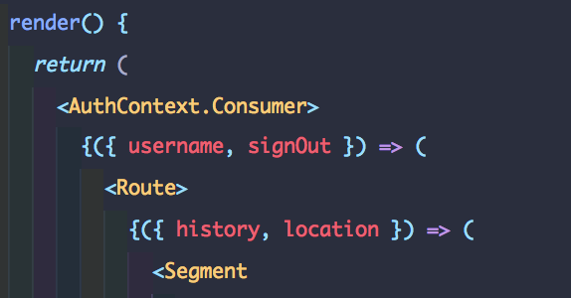
Sharing code via functional children
Because of that, the title can be more aptly renamed as “Code-sharing in React using functional children props”.

The problem
Since React embraces FP-style composition over inheritance, in the early days, the composition was mostly done using compose and statically. And libraries like recompose made it really easy and straightforward. If you wanted to write components that were stateless and pure functions, you would write something like:
This was mostly better than sprinkling this.setState everywhere as it made it easy for components to be “dumb and pure” and logic to be abstracted to seperate functions that could be tested independently. But it had it’s own problems.

1. Who put what in props?
Since so many things are injected via “props”, it becomes harder to reason which composition injected what as the component becomes larger.

2. Re-location of logic
Co-located code is easier to read. But since some of my logic is re-located to a place far away from it’s actual (and often times only) usage, it becomes harder to read things.

3. Lack of type inference
This was my personal favorite gripe. As a heavy user of Typescript, I ended up spending a lot of time trying to find a way to have robust types without writing a lot of my own types — but had little to no return from it.

A solution
Instead of providing re-usable logic via props, what if we can provide it via a children function?
Let’s say I want the current date, updated every second to be shared across my React app. I’d write a LiveDate component like this:
Normally, children would be a JSX expression. But here we assume children to be function. And the caller of that function would get the { date: “…” } object.
Albeit, this is such a simple example. But see if we share code this way, it solves all 3 of the above problems.
- Re-usable logic is provided to the consumer as a React component, not polluting the props.
- We know who provides liveDate as it’s very much co-located.
- Type inference needs next to no effort because type systems can infer the type of liveDate based on the definition of LiveDate component.

Fragments :
We have seen how do we create components in React and how do we return elements from the Component. But any component we create in React, can only return one element. Now what will happen if we return multiple elements from one Component. React will throw us an error. But it is very common scenario we face in our day to day programming life that we want to return multiple elements from one component.
It might be creating a component which is responsible for iterating through a list and returning multiple table row elements or iterating through an object and returning multiple td elements or returning multiple div containers.
render() {
return (
<React.Fragment>
<ChildA />
<ChildB />
<ChildC />
</React.Fragment>
);
}

React Props.Children:
More often that not, components need to communicate between each other by passing data from a component to another or from a parent component down the tree.
You can pass data down to a child component via its props which is short for properties.
React has a powerful composition model, and we recommend using composition instead of inheritance to reuse code between components.
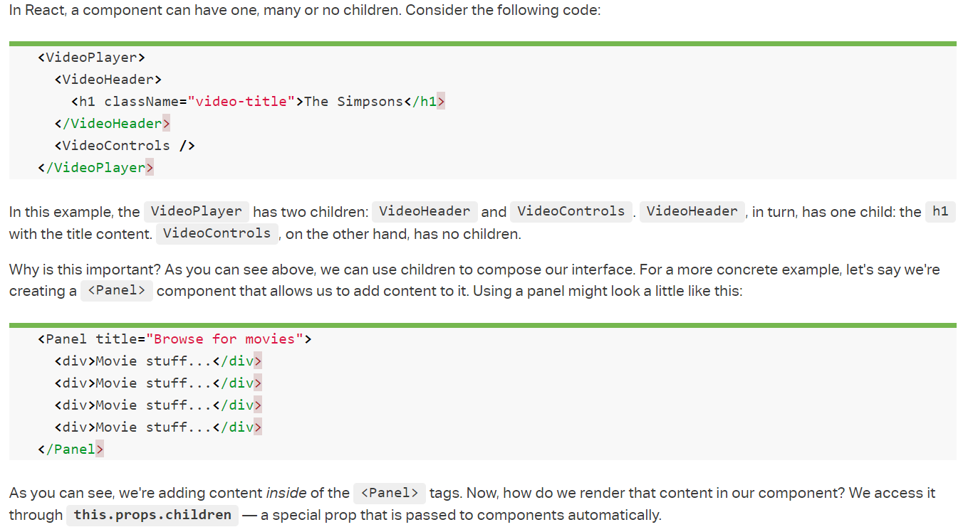

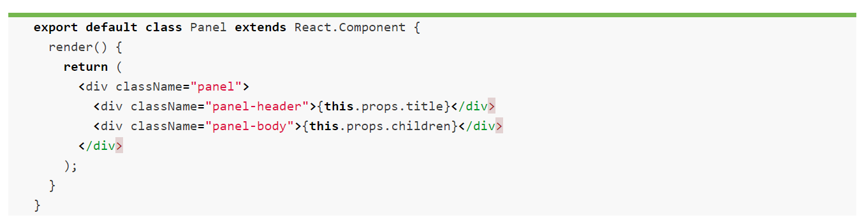

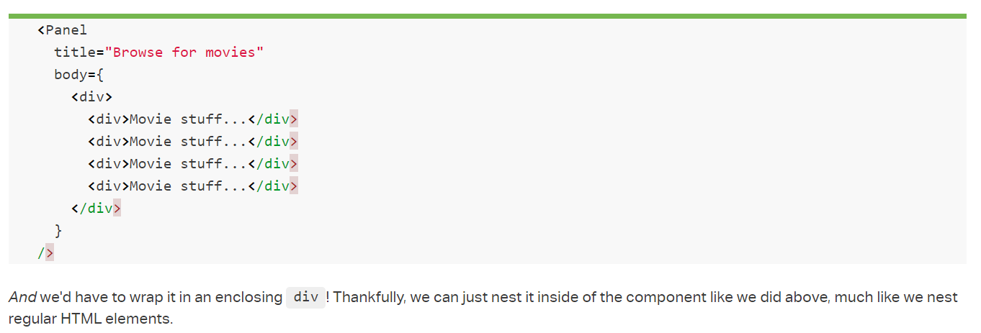

Error Management (Error Boundary):
Error Boundaries were introduced in React v16 as a way to catch tricky errors that occur during the render phase. In the past this would have caused the app to unmount completely, and the user would just see a blank web page.
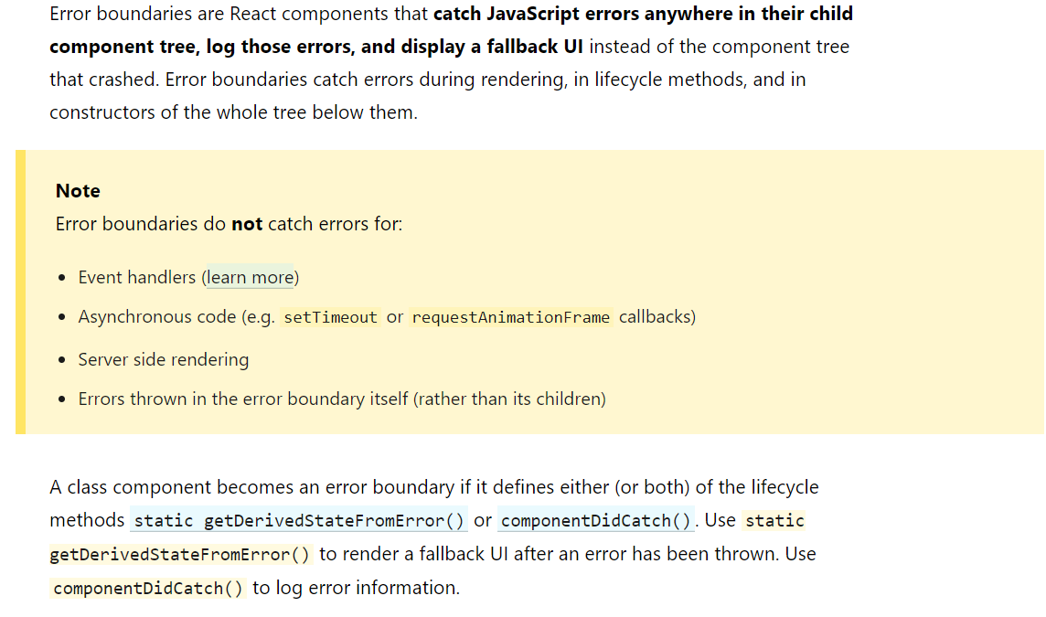
Error Boundaries are only designed for intercepting errors that originate from 3 places in a React component:
- During render phase
- In a lifecycle method
- In the constructor
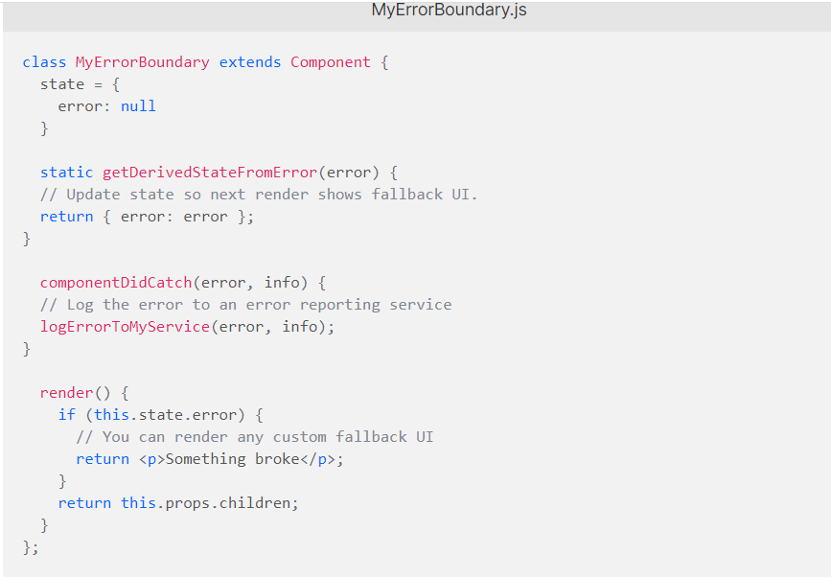
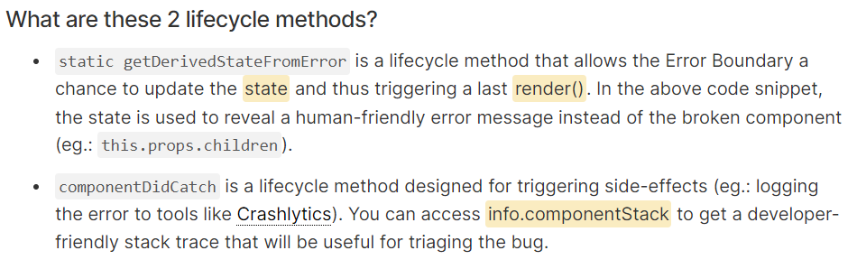
So what is an Error Boundary?
“Any React Component is considered an Error Boundary when it employs at least one of these lifecycle methods.”
Error boundaries are React components which catch JavaScript errors anywhere in our app, log those errors, and display a fallback UI. It does not break the whole app component tree and only renders the fallback UI whenever an error occurred in a component. Error boundaries catch errors during rendering in component lifecycle methods, and constructors of the whole tree below them.

Single vs multiple Boundaries
When you wrap a component tree with a single Error Boundary, the entire tree gets affected by errors caught in just one of the components. Take an example:
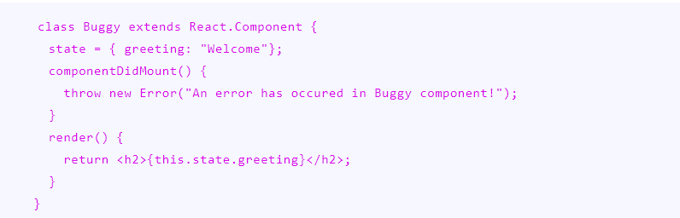
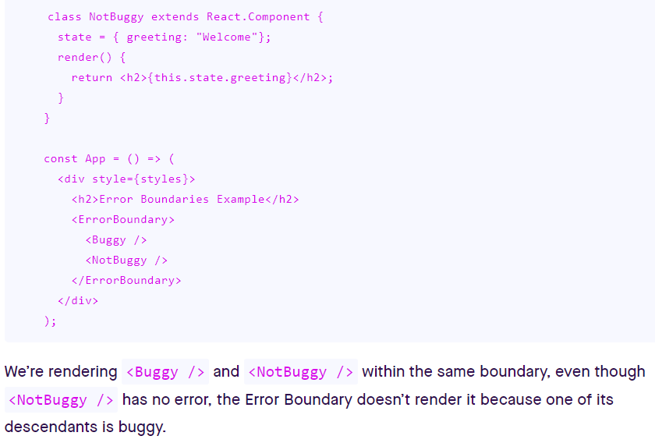
Solution:
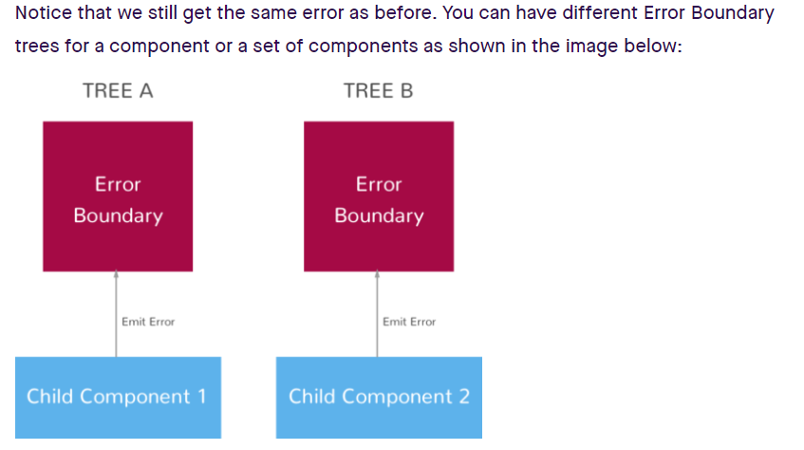
Now try separating the two components to have their own respective ErrorBoundary component:

How to prevent re-renders on React functional components with React.memo()
If you’re using a React class component you can use the shouldComponentUpdate method or a React.PureComponent class extension to prevent a component from re-rendering. But, is there an option to prevent re-rendering with functional components?
The answer is yes! Use React.memo() to prevent re-rendering on React function components.

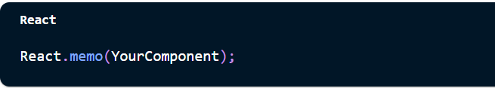

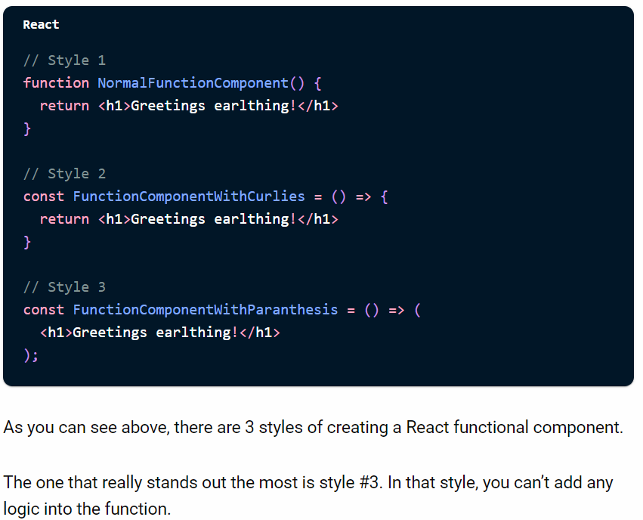

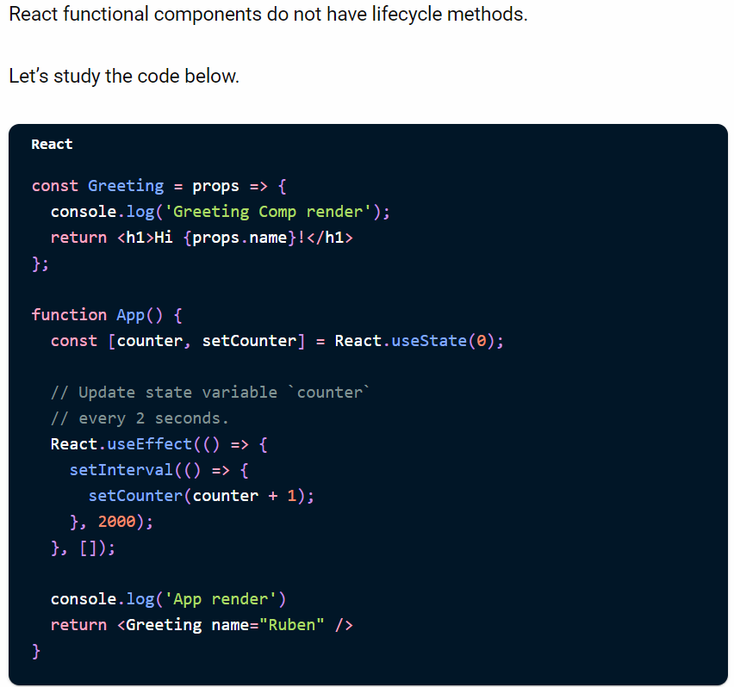

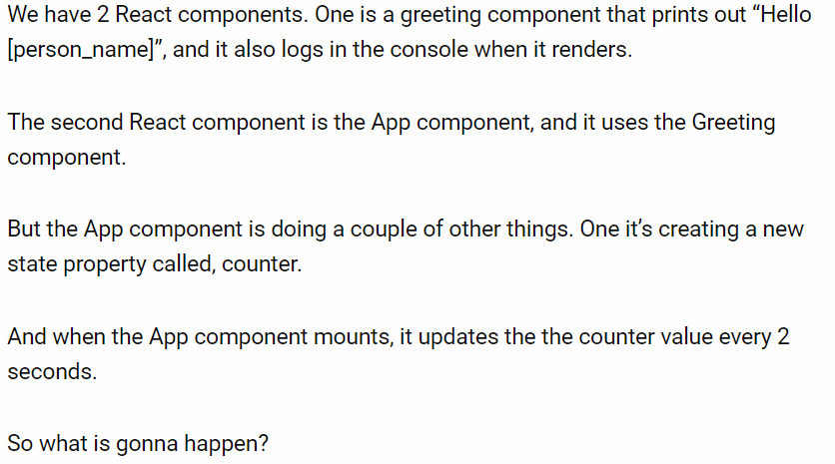

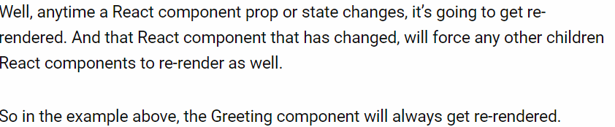

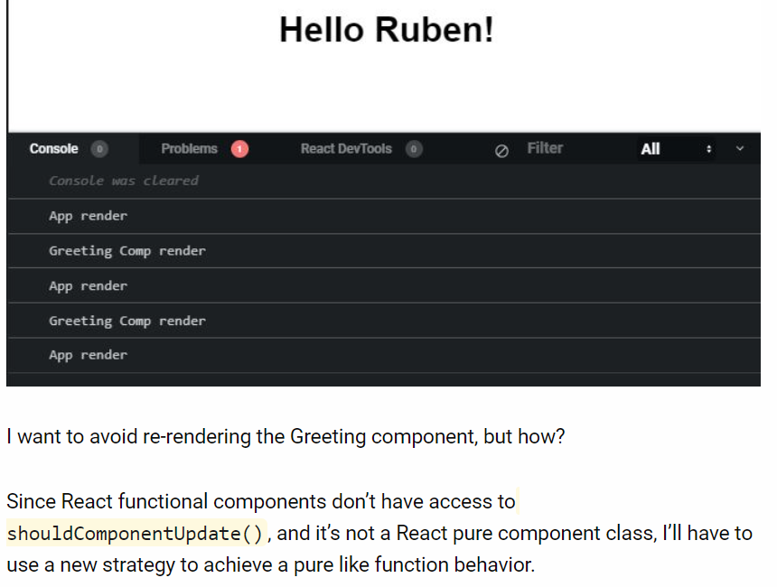

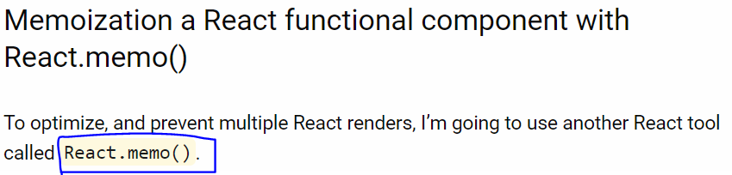

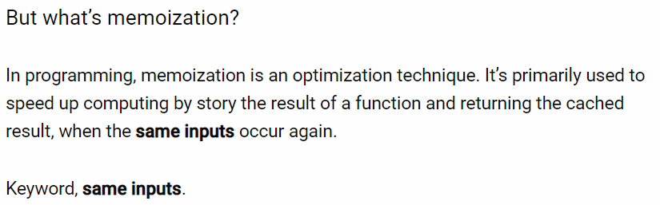

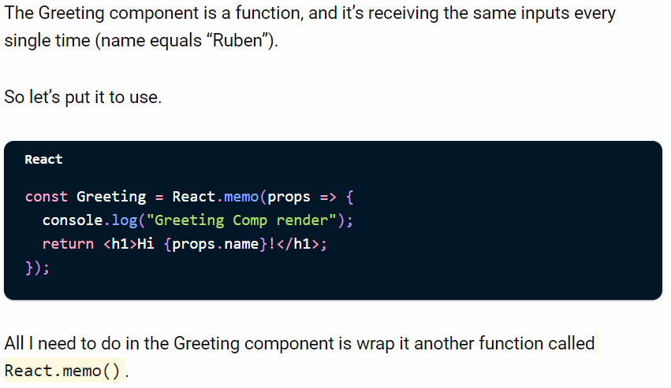

Global & Local Shared Data

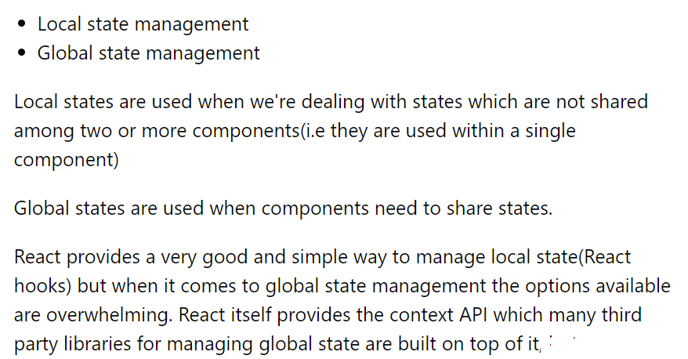

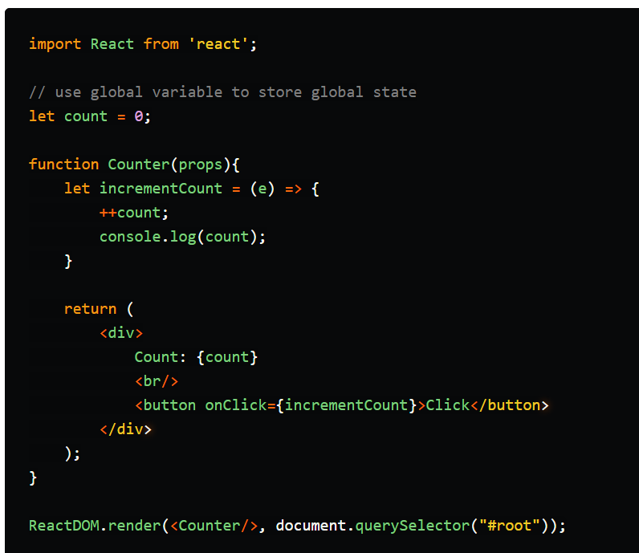

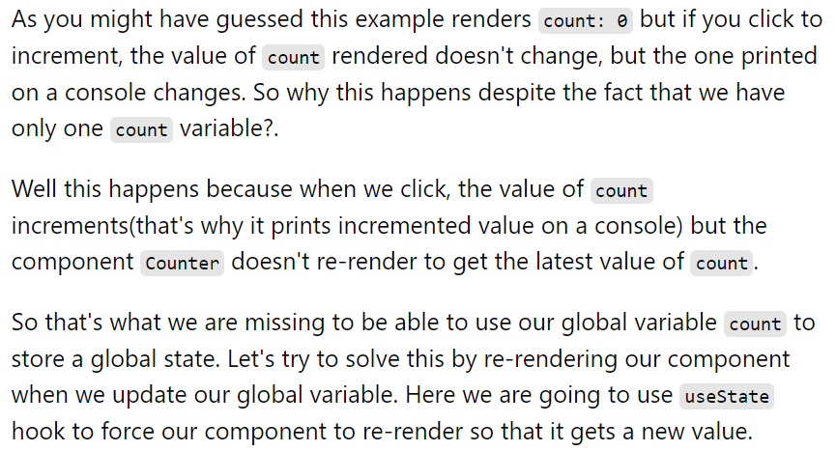

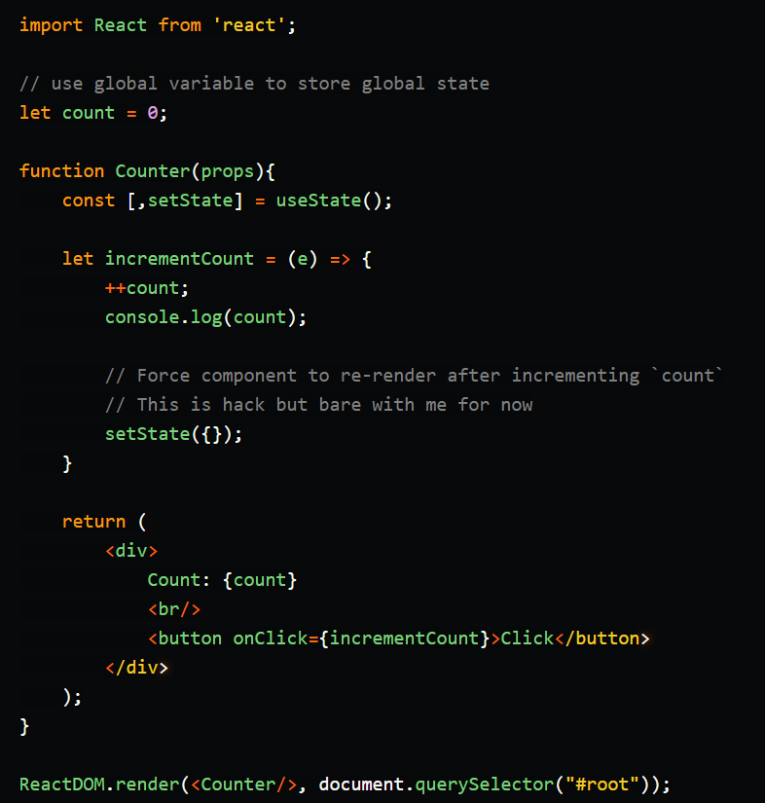

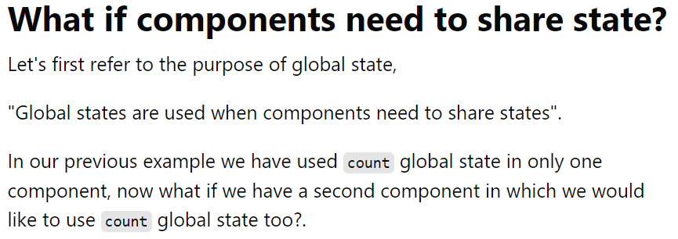

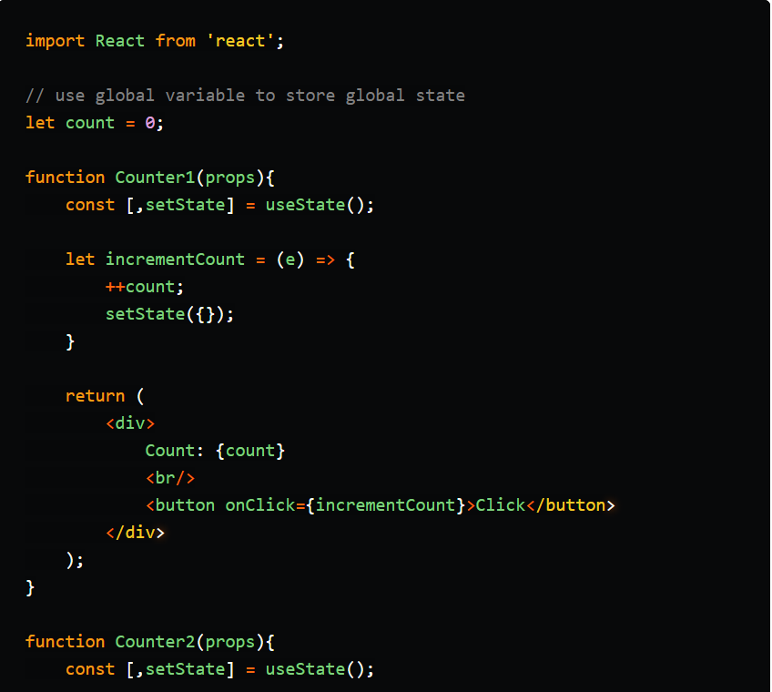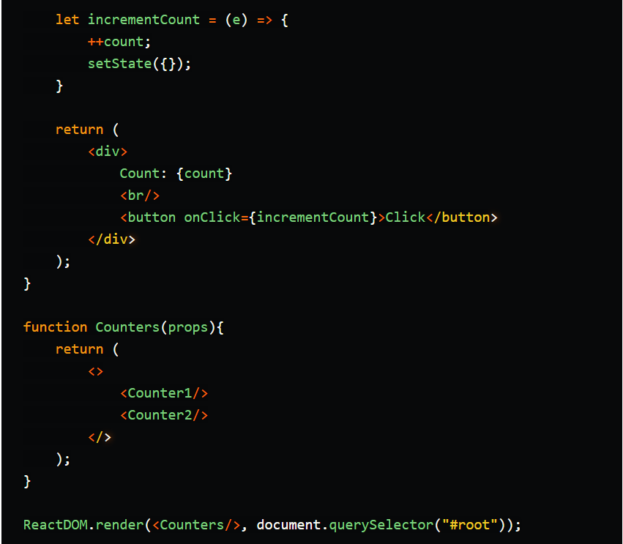

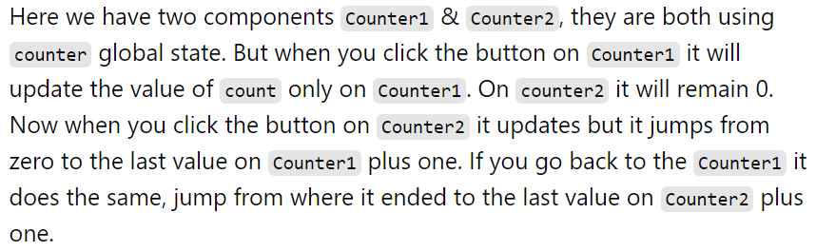

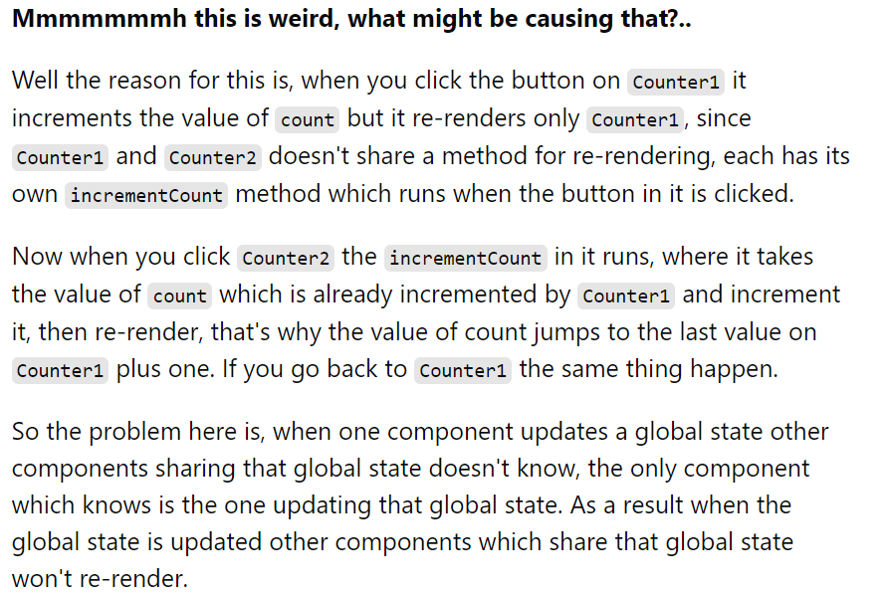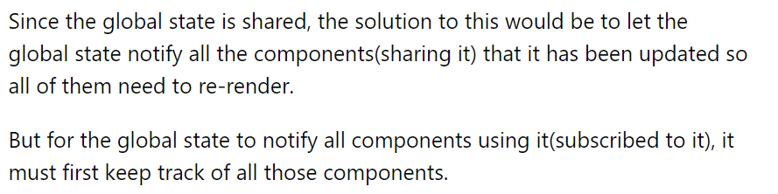
Steps to simplify the process will be as follows:
- Create a global state(which is technically a global variable)
- Subscribe a component(s) to a created global state(this lets the global state keep track of all components subscribed to it)
- If a component wants to update a global state, it sends update request
- When a global state receives update request, it performs the update and notify all components subscribed to it for them to update themselves(re-render)

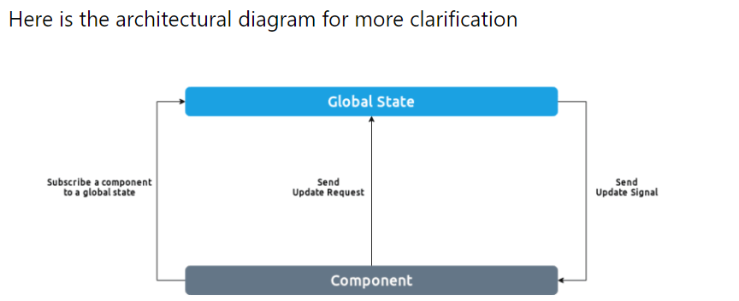

React Hooks

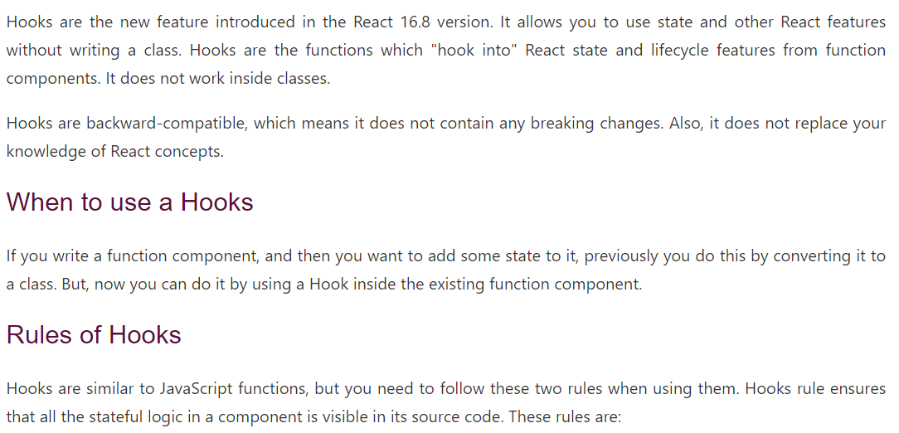
Before we create our own Hook, let's review a few of the major rules we must always follow.
- Never call Hooks from inside a loop, condition or nested function
- Hooks should sit at the top-level of your component
- Only call Hooks from React functional components
- Never call a Hook from a regular function
- Hooks can call other Hooks ( custom hooks)

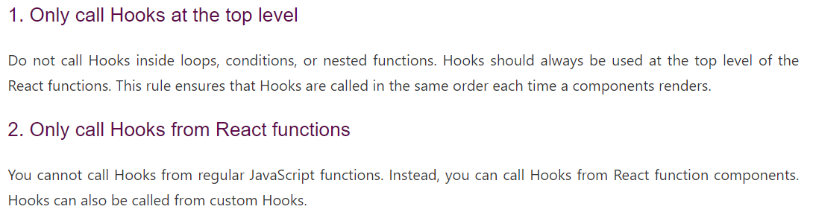

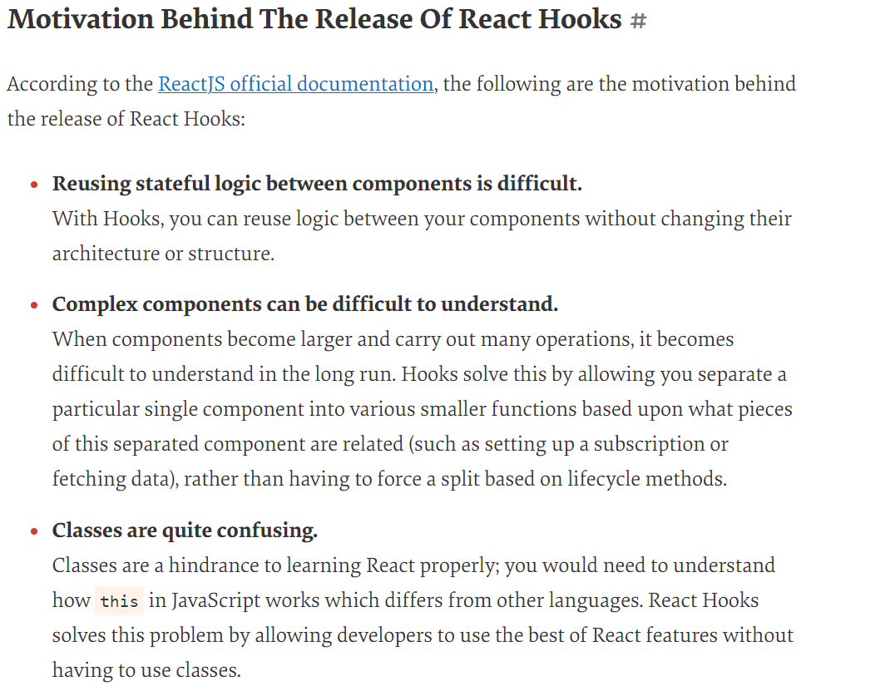

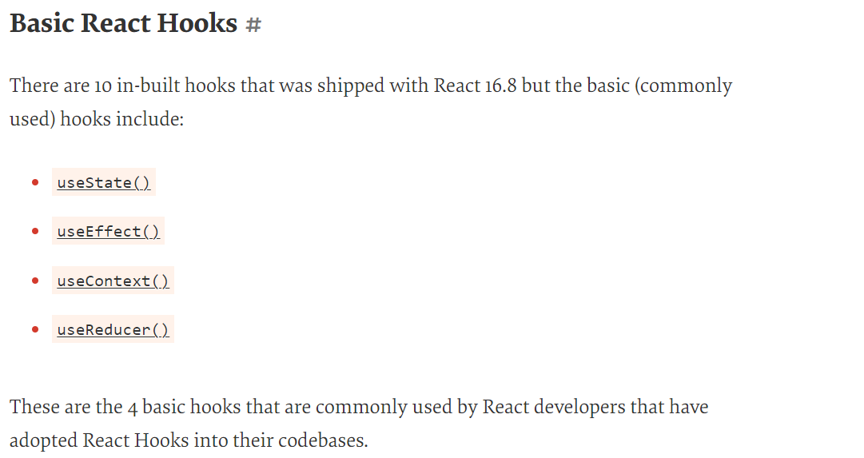

useState():

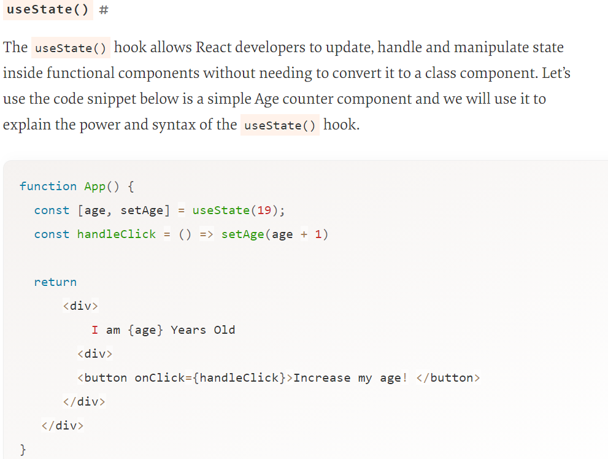
This is how our component should look when it is rendered in our React application. By clicking on the “Increase my Age” button, the state of the age will change and the component would work just like a class component with state.

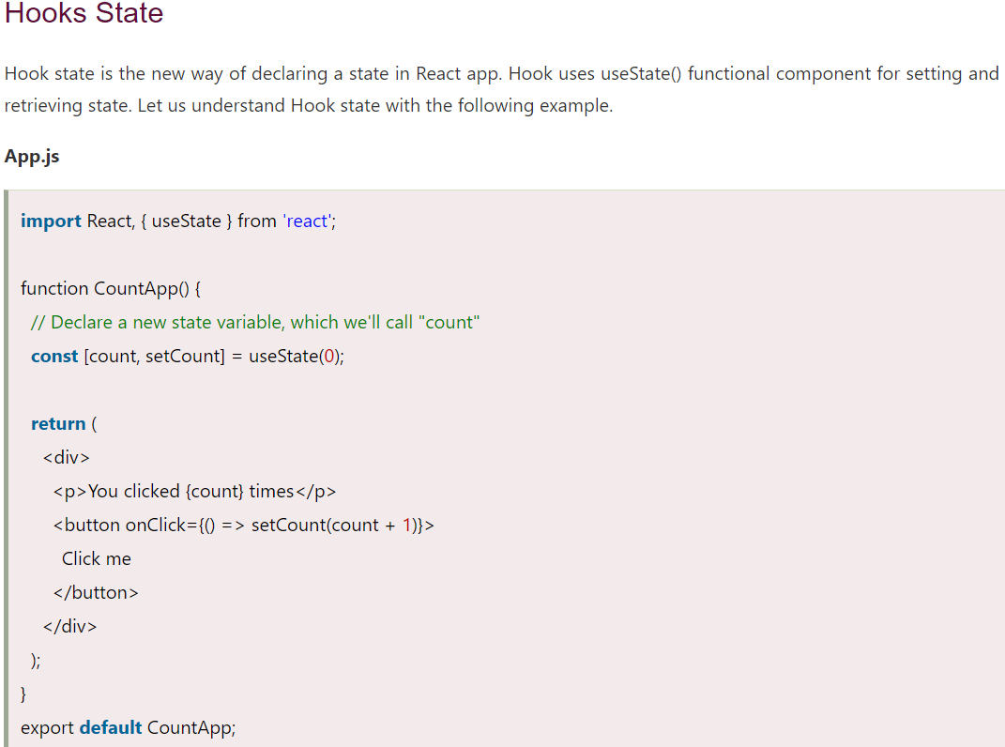

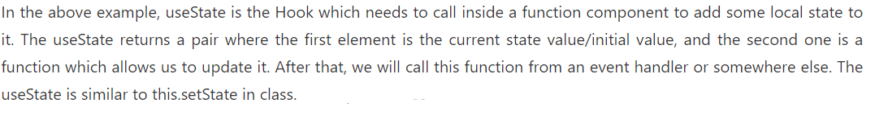

useEffect():

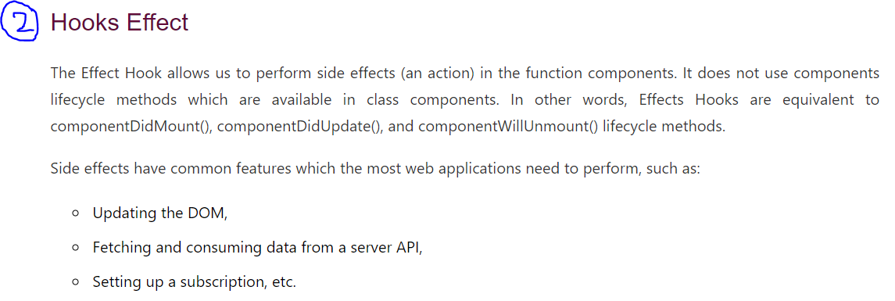
Add below code to the above code of useState:
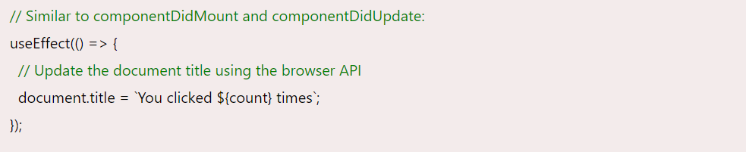
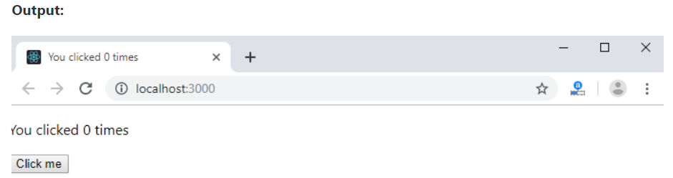

The above code is based on the previous example with a new feature which we set the document title to a custom message, including the number of clicks.

The useEffect() hook accepts a function that would contain effectual code. In functional components, effects like mutations, subscriptions, timers, logging, and other effects are not allowed to be placed inside a functional component because doing so would lead to a lot of inconsistencies when the UI is rendered and also confusing bugs.

The useEffect() hook mostly into play for side-effects that are usually used for interactions with the Browser/DOM API or external API-like data fetching or subscriptions. Also, if you are already familiar with how React lifecycle methods work, you can also think of useEffect() hook as component mounting, updating and unmounting — all combined in one function. It lets us replicate the lifecycle methods in functional components.
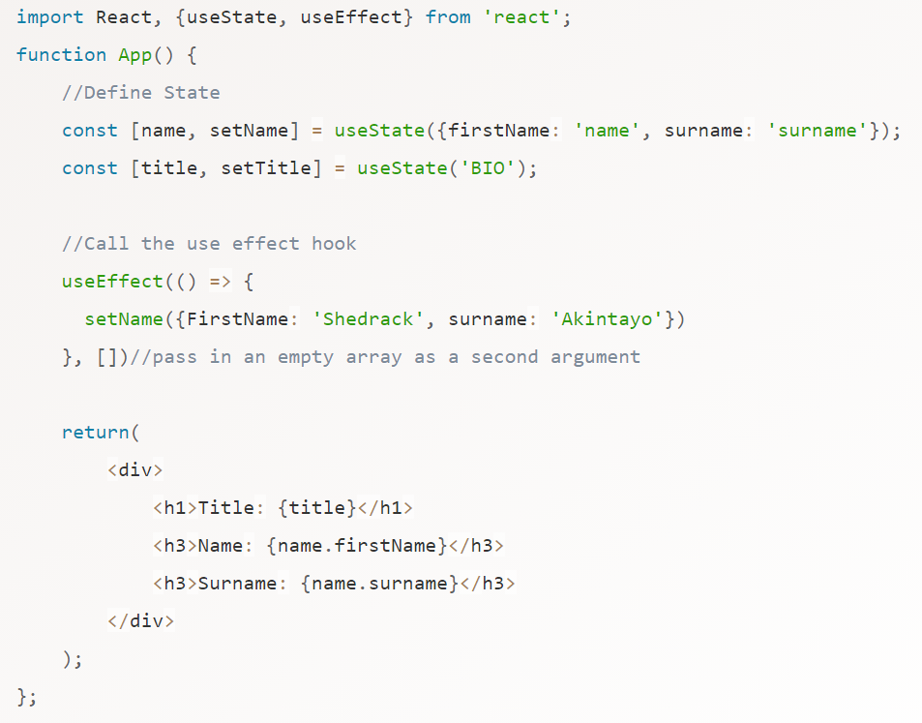

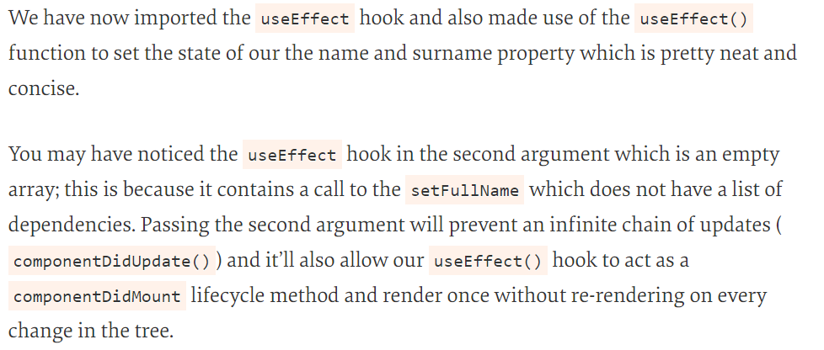

useContext():

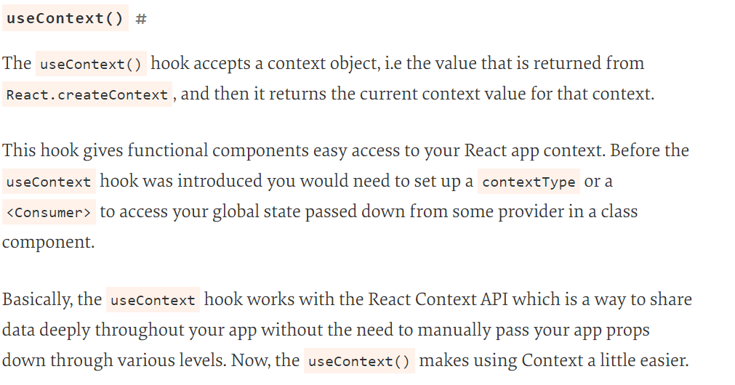

React Context:
(First Understand this then move to useContext())

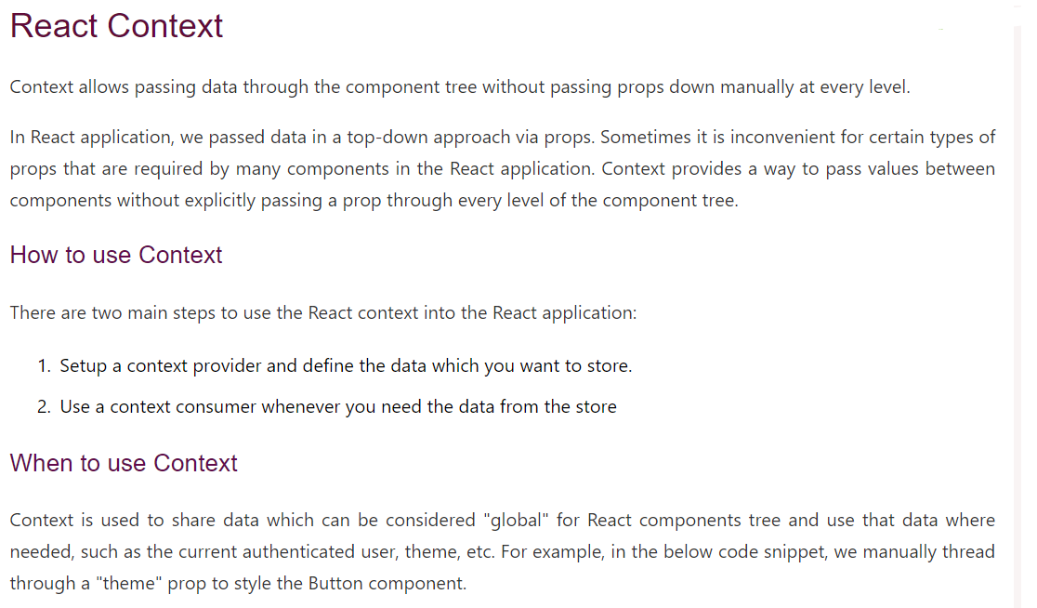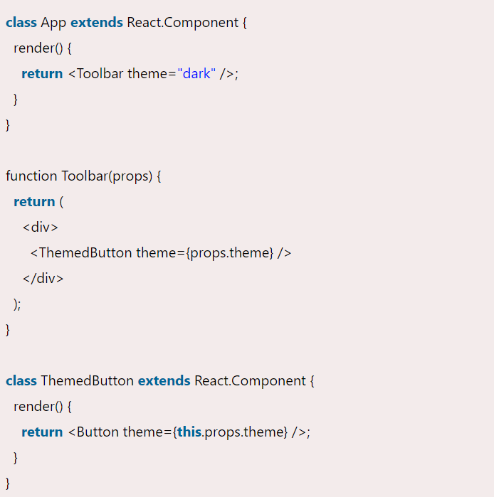

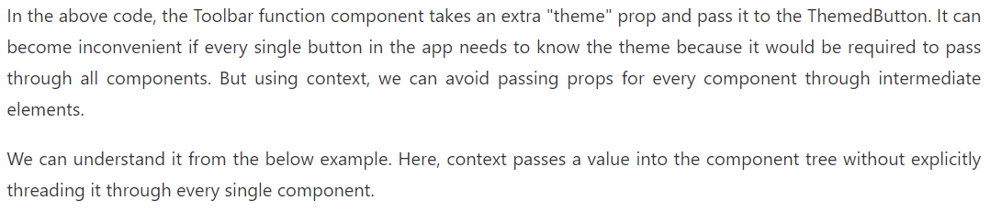

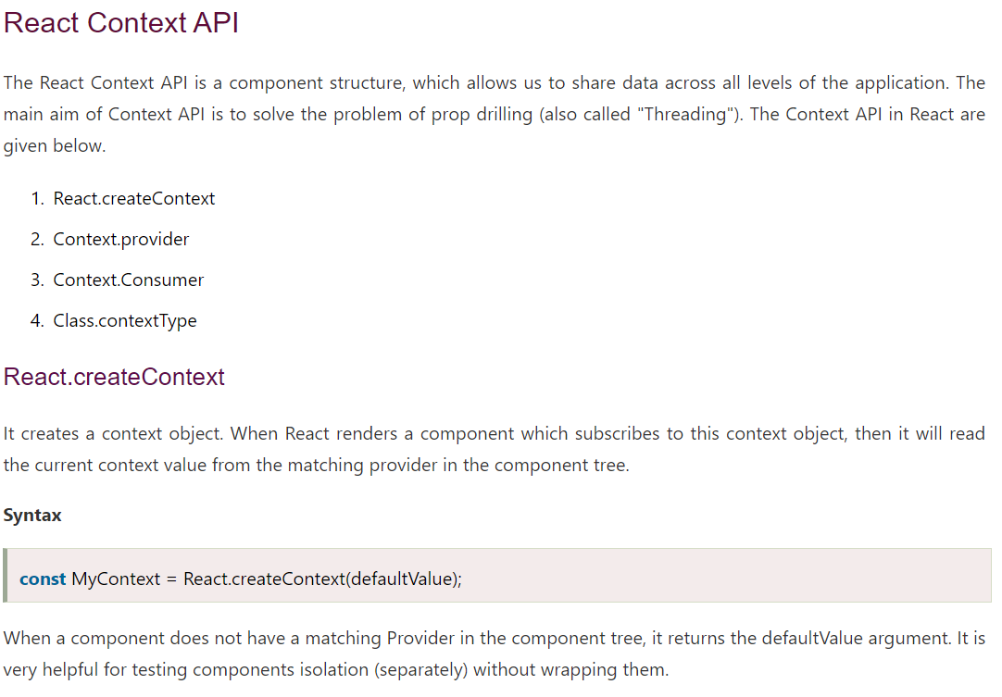

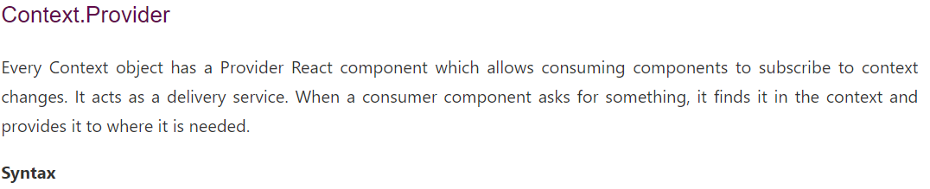

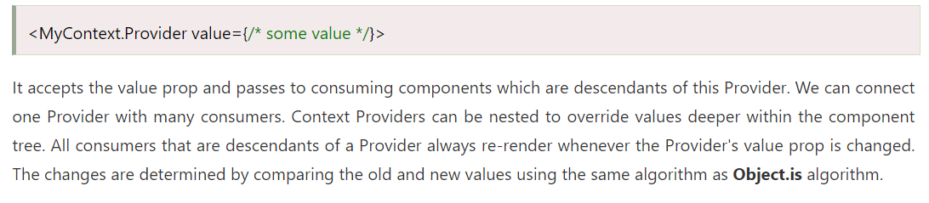

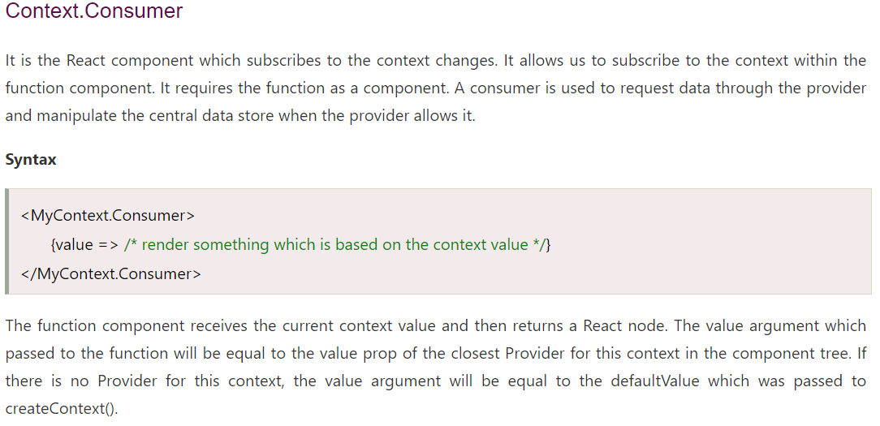

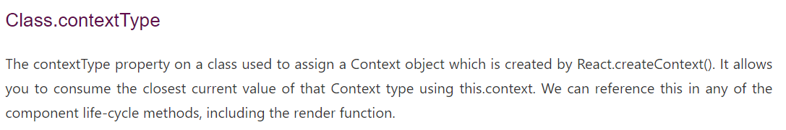

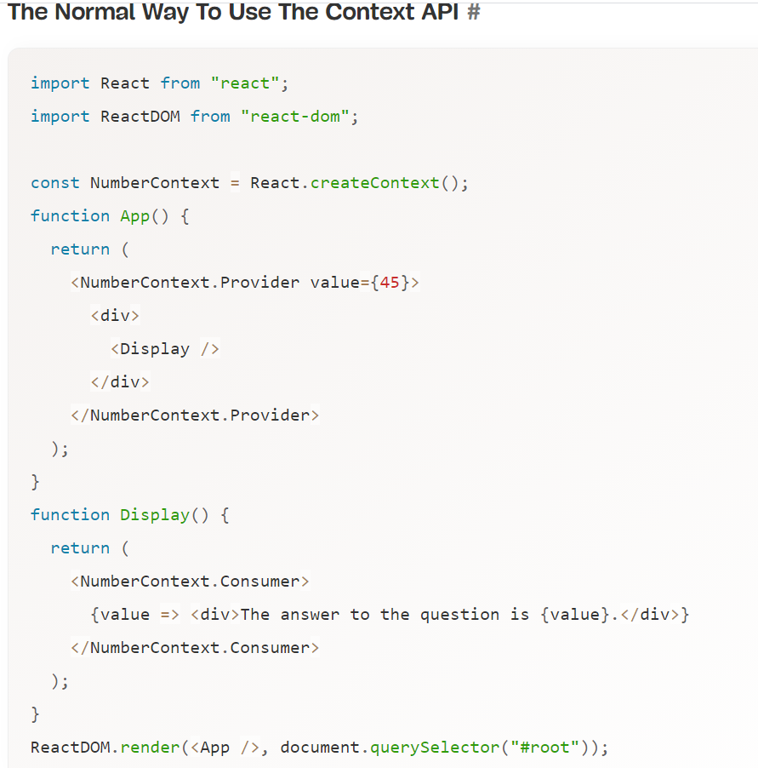

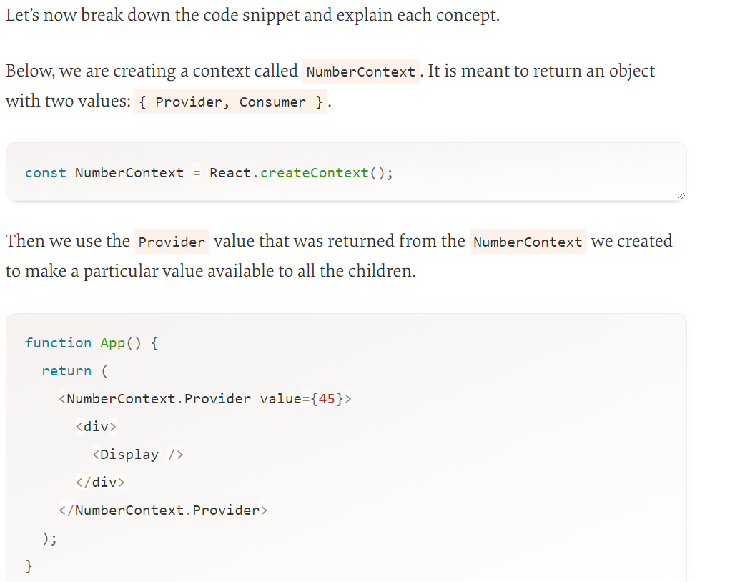

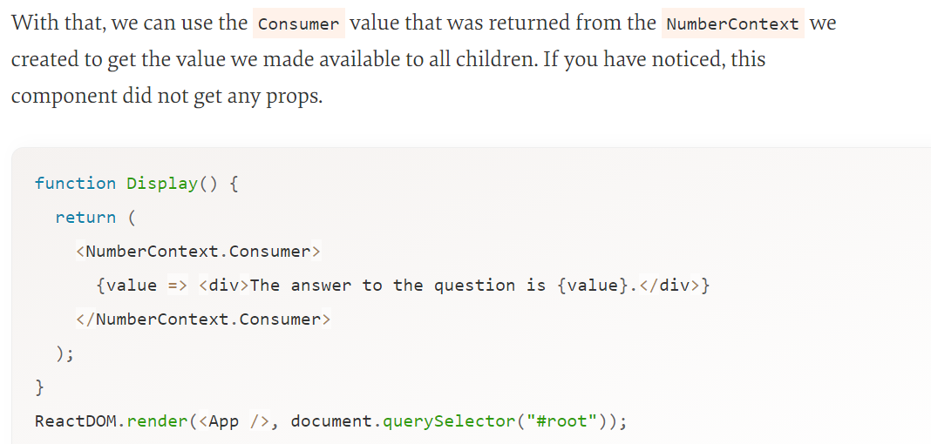

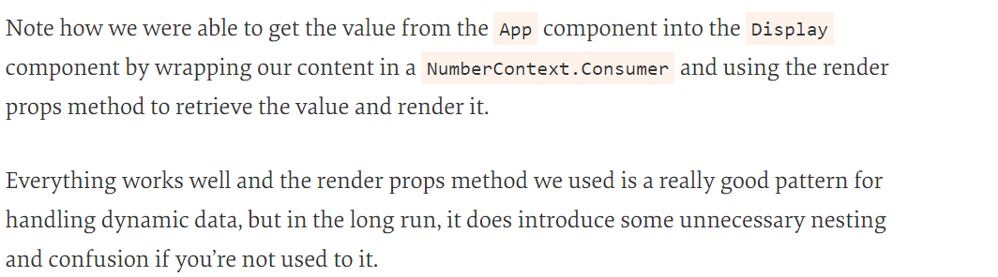

Solution : useContext()

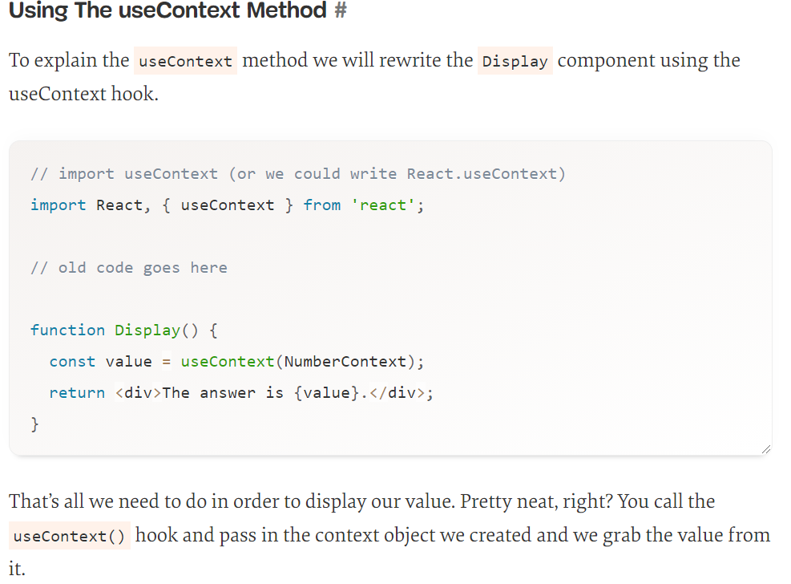

useReducer():

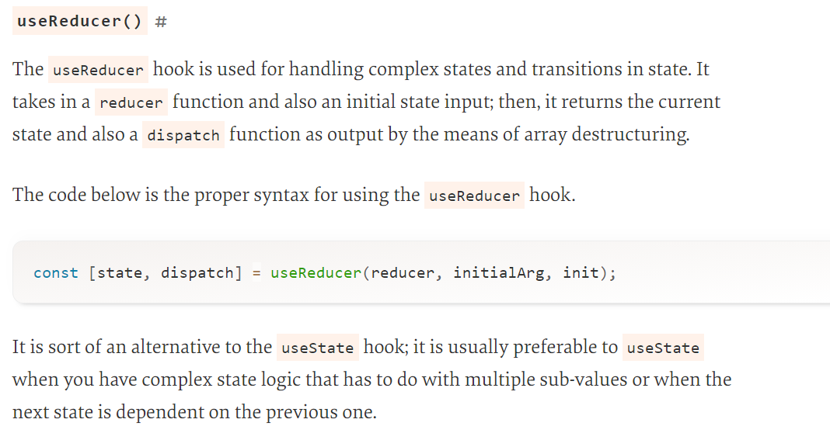

Portals

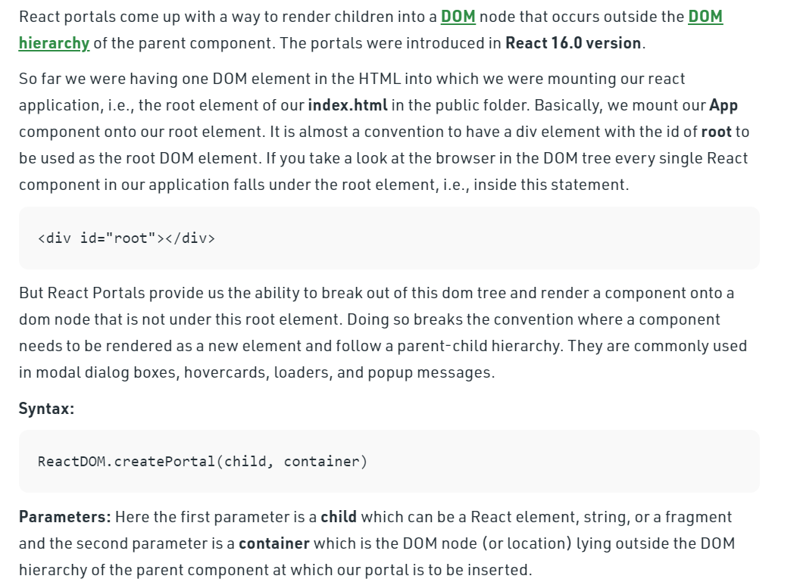

Example before React v16
Generally, when you want to return an element from a component's render method, it is mounted as a new div into the DOM and render the children of the closest parent component.

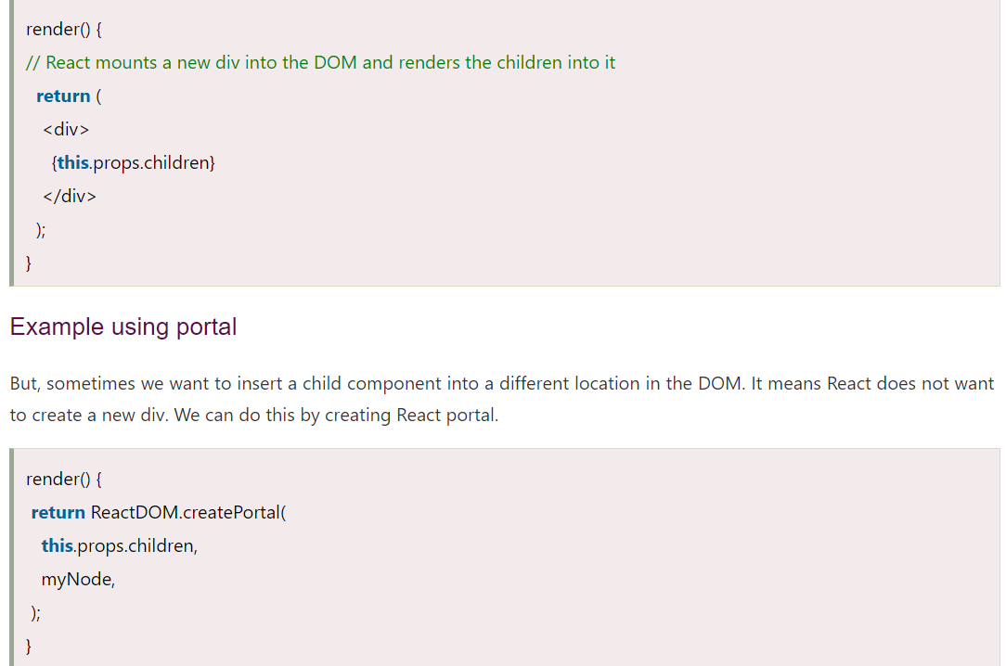

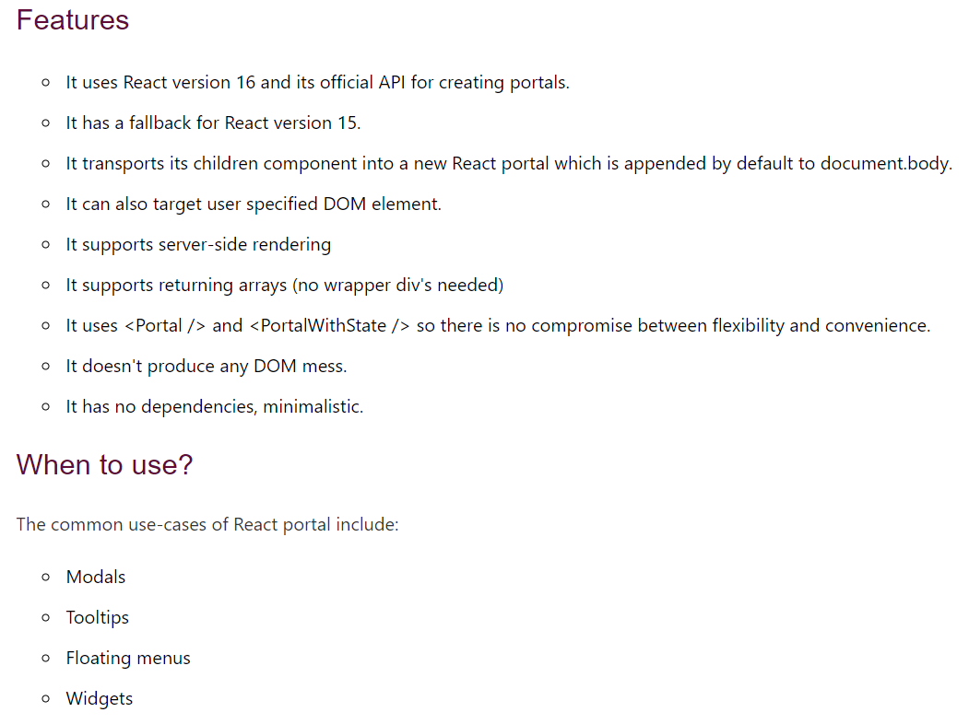

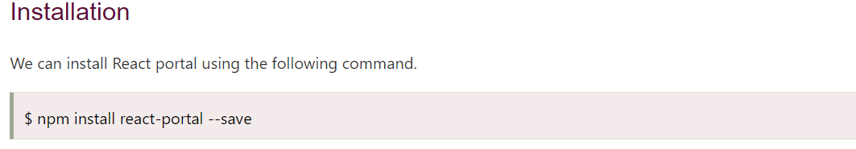

Handle Async Data Loading, Lazy Loading with React

As a JavaScript web developer, asynchronous code gives you the ability to run some parts of your code while other parts are still waiting for data or resolving. This means that important parts of your app will not have to wait for less important parts before they render. With asynchronous code you can also update your application by requesting and displaying new information, giving users a smooth experience even when long functions and requests are processing in the background.
In React development, asynchronous programming presents unique problems. When you use React functional components for example, asynchronous functions can create infinite loops. When a component loads, it can start an asynchronous function, and when the asynchronous function resolves it can trigger a re-render that will cause the component to recall the asynchronous function.
how to avoid this with a special Hook called useEffect, which will run functions only when specific data changes. This will let you run your asynchronous code deliberately instead of on each render cycle.
Asynchronous code is not just limited to requests for new data. React has a built-in system for lazy loading components, or loading them only when the user needs them. When combined with the default webpack configuration in Create React App, you can split up your code, reducing a large application into smaller pieces that can be loaded as needed. React has a special component called Suspense that will display placeholders while the browser is loading your new component. In future versions of React, you’ll be able to use Suspense to load data in nested components without render blocking.
In this tutorial, you’ll handle asynchronous data in React by creating an app that displays information on rivers and simulates requests to Web APIs with setTimeout. By the end of this tutorial, you’ll be able to load asynchronous data using the useEffect Hook.

